,,

UNIVERSITY *of* WEST FLORIDA Volume XXIII I Spring 2020

**Leisure Learning**



Spring 2020 Course Guide

**Nature Awai s!**

* Indian Temple Mound Museum
* Pensacola Backyard Homestead
* Roy Hyatt Environmental Center Tour
* Weeks Bay Reserve Pontoon Boat Tour

**plus**

* Beginning Portrait Dra
* Bodacious Shops
* Historic Pensacola

**and more!**

**Why join Leisure Learning?**



For more than 20 years, UWF Leisure Learning has provided stimulating programs for seasoned adults who are interested in joining a spirited community of intellectual contemporaries and lifelong learners.

Our diverse lineup of classes offer you the opportunity to explore Pensacola and the surrounding areas, discover exciting research and ideas or learn new skills — all while making friends.

**Become a member and start attending class this Spring!**

* 1. Review this catalog and select your classes.
  2. Register and pay for your annual membership

and individual classes in one of 3 easy ways. (Page 33)

* 1. Learn more about Nautilus Card benefits

for UWF Leisure Learning members. (Page 35)

* 1. **Enjoy class!**

**Spring classes start Jan. 13th!**

How does the UWF Leisure Learning membership work?

**The $35 annual membership fee covers**

**12 months from the date you join. With your membership, you are entitled to:**

* Register for all Leisure Learning classes, tours and events.
* A Leisure Learning Parking Decal for parking on the UWF Pensacola campus.
* A class catalog mailed to you every semester.

Learn more about membership perks on Page 35!

**Questions? Call us at 850-473-7468.**

**Three Easy Ways to Register:** Register for classes online at **uwf.edu/LeisureLearning**, call us at 850-473-7468 or mail in the registration form located in this catalog. More on Page 33.

**Connect with us on Facebook!**

facebook.com/uwfleisurelearning

**Give the Gift of Lifelong Learning**



Buy a Leisure Learning membership gift card! Call 850-473-7468 to order.

**Leisure Learning** is a program of UWF Continuing Education, a premier regional provider



of high-quality credit and non-credit courses, community programming, customized training, CEUs and conference planning. **uwf.edu/continuinged**

2 **uwf.edu/LeisureLearning** | 850.473.7468 | Spring 2020

# Leisure Learning Director Spotlight

Rhonda Robinson has been the

Leisure Learning Director for six years. A New Mexico native, Rhonda moved to Pensacola from Roswell, NM in 2012. She loves cats more than dogs, and her hidden talent is her ability to play piano by ear, despite not being classically trained!

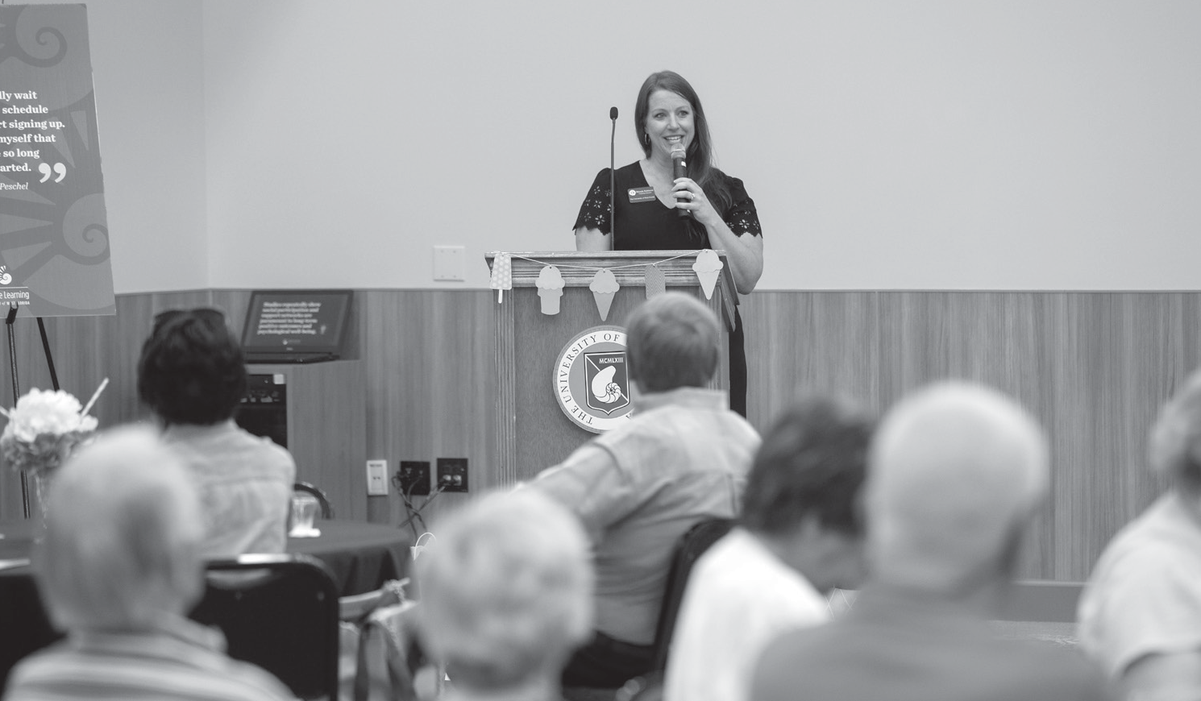

**Read on to learn more about Rhonda and her work with Leisure Learning.**

**Tell us a little about yourself and your professional experience?**

I was a stay at home mom for 13 years before I started as Director of Concert Operations for the Roswell Symphony Orchestra, where I was in charge of managing musicians and concert schedules, marketing, graphic

design and general operations. I started with UWF Leisure Learning after our family moved to the area. My previous experience at the Orchestra made me

a good fit for this position. Initially, I worked part-time assisting the current Leisure Learning Director. When the Director retired within a few years, I took over the program. About that same time, I decided to go back to school to get my bachelor's in advertising because I like to be creative. I am looking forward to finishing in May 2020!

**Tell me about your role as Leisure Learning's director.**

I stay busy coordinating the schedule and managing all of the classes, tours and events. I work with two other people to take course registrations and cancellations. I also stay in contact with presenters and attend as many events as possible. Being present helps me to not only become better acquainted with the presenters and business owners, but it also helps me interact with members to get to know them better.

**How do you come up with new ideas for courses?**

I listen to current presenters for some tidbit of unique experience or knowledge they may have that could

translate into another course. I also ask our members to email me or talk to the volunteers in class if they have any ideas for new courses.

**What is your favorite or most rewarding part of your job?** Witnessing relationships form between members. I see people who moved

here without knowing anybody attend a Leisure Learning course on a topic they find interesting to find themselves surrounded by people that share the same interest. That's all it takes for a

relationship to begin—a shared interest, no matter how small. I have also noticed members exchanging phone numbers in class and have later run into them out in the community together.

The relationship aspect is the reason we do what we do; the social element that extends outside our classes.

**What would you say sets UWF Leisure Learning apart?**

Leisure Learning provides members a “front-row seat to the community.”

In the past year, we've offered a course

**UWF Leisure Learning Director Rhonda Robinson speaks to the crowd at the 2019 Annual Leisure**

**Learning Ice Cream Social.**

led by the city planning committee to discuss the construction of the new Pensacola Bay Bridge, and a discussion with the mayor to hear more about upcoming initiatives in Pensacola. How often do you have an opportunity to talk one-on-one with the mayor? Even if it's just briefly after class, Leisure Learning provides members the opportunity to connect with someone they usually wouldn't be able to.

**What impact does Leisure Learning have on its members and the community?**

On an individual basis, it's essential because it keeps people from becoming isolated after retirement. It provides

an outlet to stay social and learn new things. I think the community benefits because this age group has a voice that needs to be heard, and Leisure Learning facilitates that connection.

**What would you tell someone considering joining?**

Leisure Learning is an excellent opportunity to learn something new and interact with people their age. For individuals who are hesitant to join, they can register for a class with a free 30-day trial membership to see if they like the program.



## Volunteer to be a Leisure Learning Liaison!

Leisure Learning is growing at an exciting rate. This has presented a fantastic opportunity for you to become more involved in the classes you are already attending!

We are looking for social, enthusiastic volunteers to become Liaisons for Leisure Learning. **The best part — you will only be contacted for classes that you are already attending.**

This is an easy way to be involved and get to know your fellow Leisure Learners.

Primary Liaison duties include:

* Taking attendance
* Introducing speakers
* Delivering announcements
* Ensuring class ends on time

**We are now accepting volunteer sign-ups for**

**Leisure Learning Liaisons! Contact us at 850.473.7468 or email** [**LeisureLearning@uwf.edu.**](mailto:LeisureLearning@uwf.edu)

**TOPICS AT A GLANCE SPRING 2020**

**Arts and Literature**

Beginning Portrait Drawing 12

Bodacious Bookstore and Cafe 6

Calling All Bookies 6

Charcoal Drawing with Larry Manning 21

Communication Through Dance 14

Conte Crayon Drawing with Larry Manning 22

Create-a-Craft: Sea Angels 26

How Did Artists Gain Perspective? 28

Learning to Play the Recorder 6

Lunch 'N' Learn: Meet the Artists of *Don Giovanni* 7

Lunch 'N' Learn: Meet the Artists of *Il Trovatore* Back Cover

Pensacola Museum of Art: John Markowitz 11

Quayside Art Gallery 6

Recorder Ensemble Series 6

Voices of the American Spirit: Willa Cather 9

**Business, Finance and Technology**

Laughter and Leading 8

Plan for your Future, Make it Happen 14

Planning for Long Term Care 13

Tax-Free Investing: It's Not What You Make,

It's What You Keep! 26

**Culinary and Food**

Angelena's Restoranto Italiano 10

Bodacious Chef: Nick Farcas 11

Bodacious Shops — Wine and Cheese 15

Hot Spot Barbecue 10

McGuire's Irish Pub & Brewery Tour 24

**Culture, Travel and Tours**

Bavarian's Wirtshaus and

Destin History & Fishing Museum 22

ECUA Recycling Facility Tour 7

Historic Oakleigh House and Mobile Carnival Museum* 28

Historic Pensacola Village Tour 14

Humming Star Alpacas 25

Indian Temple Mound Museum 9

Pensacola Yacht Club History 16

Scenic Highway Trolley Tour 24

St. Michael's Cemetery 8

Storybook Castles and Fairhope History Museum 21

Swift-Coles Historic Home Tour 9

Uncle Sandy's Macaw Bird Park 12

W.R. Taylor Brick Company 24

WEAR TV 3 Tour 12

**Gardening and Environment**

Deadman's Island: Pensacola Bay's Unique Landform 11

**Calendar 17**

**Class Locations & Directions 30**

**Instructors and Curriculum Council 32**

**Registration Form 33**

**Membership Information 35**

**Directions to class — see Page 30.**

Harmful Algal Blooms 28

How Does Your Garden Grow? 13

Keeping Bonsai Alive 16

Pensacola Backyard Homestead 24

Roy Hyatt Environmental Center Tour 22

Weeks Bay Reserve Pontoon Boat Tour 12

**History and Current Affairs**

America’s Cup Challenge in Pensacola 15

Anticipation 2020 27

Blue Wahoos Senior Writer: Bill Vilona 23

Chaos and Cartooning with Andy Marlette 7

Florida's Current Economic and Legislative Outlook 29

Gálvez! 8

Go Argos!: UWF Football with Florida Sports

Hall of Famer Gordon Sprague 16

Great American Speech Series: Martin Luther King Jr 14

Gulf Coast Citizen's Diplomacy Council 16

Hangar Flying: Improvements in Aviation Safety 14

Hangar Flying: Where are We? 26

Illuminated Medieval Manuscripts

and What They Reveal About the Culture 27

On the Other Hand...Current Affairs Discussions 27

Richmond: Primary Arms Producer for the South 26

Stonewall Jackson’s Shenandoah Valley

Campaign of 1862 21

Supreme Court Preview: Cases to Watch

in the 2020-21 Term 25

The Rise of the Populist Middle 27

The Voluntary Exile of Free Negroes

of Pensacola in 1858 8

Topics in Contemporary Political Science 29

UWF Archives & W. FL Center John C. Pace Library

Tour: Artists and Art 8

UWF Archives & W. FL Center John C. Pace Library

Tour: The American Presidents 21

What Ever Happened to Free Speech? 28

**Science and Health**

Bocce Ball for All 27

Divine Life Lessons: Uncovering Your Sacred Self 22

Eden Energy Medicine 10

Executive Brain and Whole Person Lifestyling 12

Finding Peace Within:

Mediation and Mindfulness for Seniors 10

Healthy Living for Your Brain and Body:

Tips from the Latest Research 26

Make a Difference: Volunteer 9

Montessori Education 101 16

Simple and Effective Art of EFT — Emotional Freedom Technique/Tapping 11

Simple and Effective Art of EFT (Part Two) 2.0 11

Tales of the Maya Skies: Pensacola State College Planetarium 24

**Directions to classes — see Page 30.**

**Mondays**

**New! Bodacious Bookstore and Cafe**

Every great downtown has a local bookstore and Bodacious Bookstore and Cafe Manager Crissy Nettles is making that come true for Pensacola. Crissy and

her family moved from Monroeville where she ran a bookstore in American novelist Harper Lee’s hometown. Meet for a tour and cozy gathering and stay for coffee or a sandwich when the class ends. Crissy will be available

after the tour for consultations to help you find the right book at the right time. Located in the Southtowne

Center, you will get your ticket stamped for free parking if you spend $5 on books or coffee.

**13-Jan | Mon 10:00 AM - 11:15 AM | $12**

Instructor: Crissy Nettles Bodacious Bookstore and Cafe

**Recorder Ensemble Series — 18 Sessions**

This multi-week course is designed for those that have already taken the Beginner Recorder series. There is a second volume to the textbook used in the beginner course ($7.95) and additional supplemental literature from the Renaissance period. Contact the primary instructor, Charles Tucker, with questions at

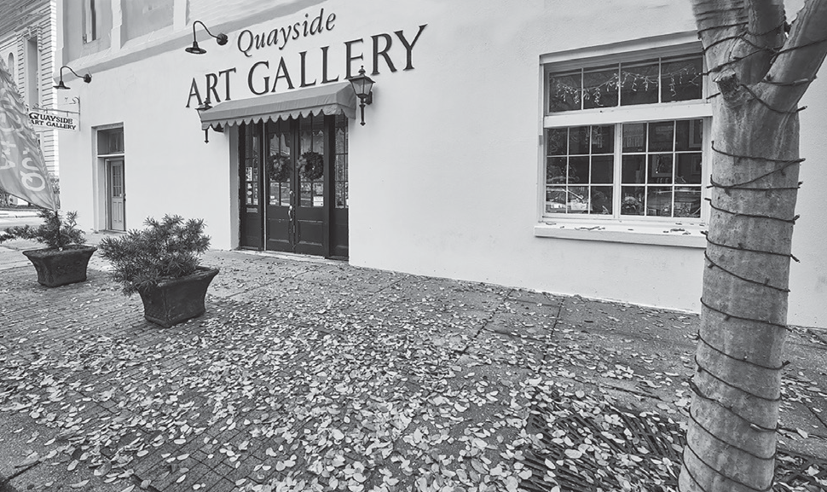

**EVENT SPOTLIGHT:**

**New! Quayside Art Gallery**

Facing Plaza Ferdinand at the corner of Zaragossa and Jefferson streets in downtown Pensacola is the largest coop gallery in the Southeastern U.S. Many say this is the best art show in town and it is free to visitors. The building was constructed in 1873 and was headquarters for the Germania Steam Fire Engine and Hose Company. You will enjoy seeing the building as much as seeing the three floors of original art! Artists will be on hand to demonstrate and answer questions after the guided tour of the

gallery. There will be time to see works in clay, glass, fiber, precious metals and wood. In addition, you will be able to see paintings in oil, watercolor mixed media pieces and photography. There is something for everyone to appreciate (and buy if you wish). Join this class and expand your horizons while admiring the works of over one hundred local artists.

**27-Jan | Mon 1:30 PM - 3:30 PM | $12**

Quayside Art Gallery

850-525-8256. Students who took the beginning classes should also contact the primary instructor prior to registering. *No class on Jan. 20.*

**13-Jan to 18-May | Mon 1:00 PM - 2:15 PM | $25**

Instructor: Charles Tucker

St. Christopher’s Episcopal Church

Calling All Bookies

We will have another exciting and thought producing discussion and this time the book will be “The Piano Teacher” by Janice Lee. Read the book and plan to contribute to the lively comments and share your emotions about this story of Hong Kong during World War II. Although the group is usually large, everyone gets a chance to speak and share with the other participants. Class attendees will also get advanced notice of the chosen summer book title! Once you become a bookie, you will come back every semester for the stimulating experience.

**13-Jan | Mon 2:00 PM - 3:30 PM | $12**

Instructor: Dr. Louise Tolbert

J. Earle Bowden Building #1

Learning to Play the Recorder — 18 Sessions

The recorder is a pleasant-sounding Renaissance flute. This multi-week course is designed for anyone (with or without previous experience in music) interested in learning how to play the recorder. By the end of the course, students will be playing simple music in four parts. Members of the St. Paul Consort will team-teach the class, building on the basics

of learning one note at a time and how to count rhythms.

Soprano, alto, tenor and bass recorders will be used. Students need to purchase a method book and a recorder. Students decide which size instrument they wish to play during the first class meeting. Playing music in a group

is an extremely rewarding experience. Commitment to regular attendance and out-of-class practice are necessary to make the most of this course for the group as well

as for the individual. Contact the primary instructor, Charles Tucker, with questions at 850-525-8256. *No class on Jan. 20.*

**13-Jan to 18-May | Mon 2:30 PM - 3:30 PM | $25**

Instructor: Charles Tucker

St. Christopher’s Episcopal Church

Chaos and Cartooning with Andy Marlette

By popular demand, Andy Marlette, cartoonist and columnist with the Pensacola News Journal is back once again! He enjoys being in the Leisure Learning line up and is always eager to spend time with our members. It seems accurate to use the same title each time Andy joins us as there is always a bit of chaos in the life of a political cartoonist and he will again share some of it with us. Last time, Andy had Leisure Learners draw with him, who knows what this visit will bring?! Please join us for some

**Connect with us on Facebook!**

facebook.com/uwfleisurelearning

fun and a better understanding of political cartoons.

**3-Feb | Mon 1:00 PM - 2:15 PM | $15**

Instructor: Andy Marlette Studer Community Institute

ECUA Recycling Facility Tour

The ECUA Interim Materials Recycling Facility (IMRF) class starts with a 30-minute presentation on why the new plant was built and how the plant process works.

The group will then drive to the IMRF for a walking tour and discussion of the plant equipment and recycling

process. Mr. Mark Buntjer, Zero Waste Energy operations manager, will provide the instruction and on-site tour

at IMRF. *Important: There are two flights of stairs and the walking tour will last approximately one hour. Participants need to wear low heeled, closed-toe shoes.*

**9:00 AM - 12:00 PM | $12**

**Session #1: 10-Feb | Mon Session #2: 16-Mar | Mon** Instructor: Jim Roberts

Emerald Coast Utilities Authority

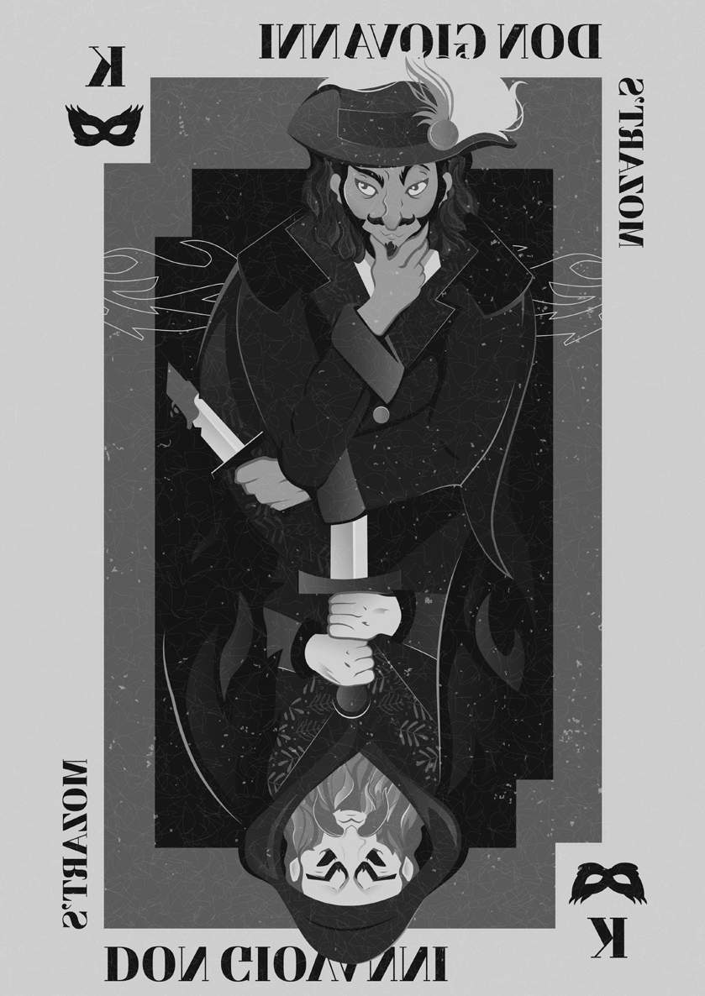**LUNCH ‘N’ LEARN EVENT:**

MEET THE ARTISTS OF

*DON GIOVANNI*

**14-Jan | Tue 11:30 AM**

**New World Landing Banquet Hall | $30**

Don Giovanni is an arrogant, charismatic aristocrat who will stop at nothing to challenge unrequited lust — even if it means violence.

His reign of terror ends in a brilliant finale as the fires of the underworld welcome opera’s lecherous libertine. Pensacola Opera's Maestro Jerome Shannon and Education Director Cody Martin

will give an overview of *Don Giovanni* and introduce the principal artists. Excerpts from the upcoming production will be performed by Pensacola Opera's Artists in Residence.

***Invite your friends and family! Leisure Learning membership is not required to attend.***

**Reservations required in advance through Jan. 7, 2020**.

*\*Not available on the all-inclusive Unlimited Classes option.*

Gálvez!

General Bernardo de Gálvez was a highly decorated Spanish military leader serving as Governor of the Louisiana in 1777. Before Spain allied with the Revolutionary War efforts, Governor Gálvez secretly supported the American Revolution cause by closing the Mississippi River to British shipping, thus shutting down all supplies to the English forces. When Spain

officially joined the colonist’s cause in 1779, now General Gálvez began an eastward campaign originating in New Orleans to drive British forces from the Mississippi River Valley and from their gulf coast forts. After taking the English forts of Baton Rouge, Natchez, and Mobile, Gálvez set his sights on Pensacola, a vital port and British stronghold on the Gulf Coast. The “Siege of Pensacola” is known as the longest battle of the American Revolution.

Since 2007, Public Historian Nancy Fetterman has labored to support the legacy of General Bernardo de Gálvez. During this lecture, Nancy will explain the relationships that started this effort, including the teamwork that made Gálvez a “Great Floridian,” and the final delicious love story behind the equestrian monument on Palafox Street which honors Gálvez as the 8th “Honorary Citizen of the United States.”

**24-Feb | Mon 10:00 AM - 11:30 AM | $12**

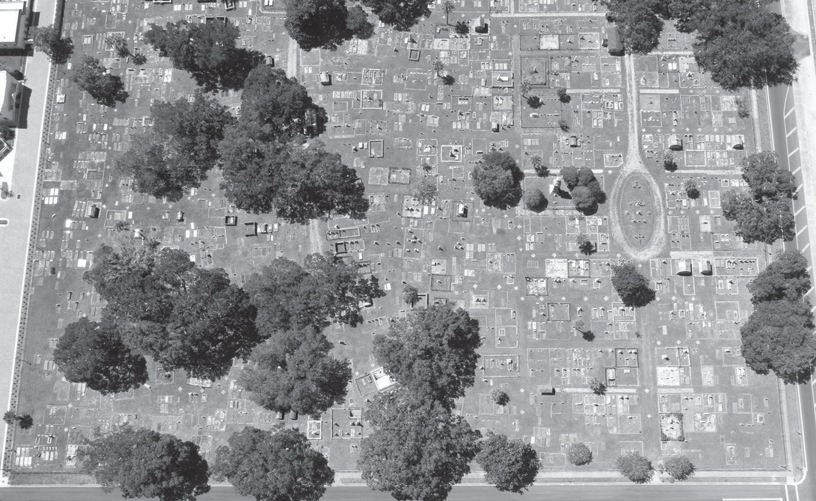

**EVENT SPOTLIGHT:**

**St. Michael’s Cemetery**

Historic St. Michael’s Cemetery is an open air museum that is a testament to the diverse history of Pensacola. Put on your walking shoes for this compelling and engaging tour. Margo Stringfield, research associate of UWF Archaeology Institute will guide us through the cemetery and share the history of the cemetery and the inhabitants. Meet at the SW gate on Alcaniz at the corner of Garden Street. Park on the corner on Alcaniz or in the lots across from the IHMC which is located at 243 Garden Street.

**2-Mar | Mon 1:00 PM - 2:15 PM | $12**

Instructor: Margo Stringfield St. Michael’s Cemetery

Instructor: Nancy Fetterman

J. Earle Bowden Building #1

New! Laughter and Leading

Participants will learn about innovative leadership by way of an insightful and hilarious collection of group activities. What can you learn about leadership from balancing a cotton ball on your head? What does a squeaky toy have to do with innovative teamwork? Sign up to find out!

**24-Feb | Mon 2:30 PM - 4:00 PM | $12**

Instructor: Dr. Athena du Pre UWF Building 86 (CEPS), TBD

New! The Voluntary Exile of Free Negroes of Pensacola in 1858

Pensacola was an island of cosmopolitan living, from the time of the revolution until 1840. Spanish, French,

English, Native Americans, many free Africans—all lived in harmony. As Florida became a slave state in 1845 things changed radically. Laws were passed statewide. Pensacola refused to go along. This is the story of the forces that were brought to bear on Pensacola, and made it change.

**9-Mar | Mon 10:00 AM - 11:15 AM | $12**

Instructor: Dave Walby

Florida Public Archaeology Network

**UWF Archives & West Florida Center John C. Pace Library Tour: Artists and Art *Pre-registration required***

Explore a hidden gem of Pensacola art history! See some of the earliest paintings of Florida life created in Florida during the Territorial Period (1821-1845) and drawings of George Washington Sully, a Pensacola cotton-broker and nephew of American painter Thomas Sully. We will also view 15th-century art and learn about other artists who visited Pensacola (Catlin, Audubon). Plus, find out if the Archives has anything “spooky” in its collections! This class is free and available to Leisure Learning members

only. *Space is limited, pre-registration is required.*

**9-Mar | Mon 1:00 PM - 2:30 PM | $0**

Instructor: Dean DeBolt

UWF John C. Pace Library UWF Archives & West Florida History Center, Basement

New! Voices of the American Spirit:

**Willa Cather — 2 Sessions**

“Flaming like the wild roses, singing like the larks over the plowed fields, flashing like a star out of the twilight.”

Willa Cather is recognized as one of the greatest writers of the 20th century, giving a voice to the American Spirit. She captures a sense of place, as she immerses us in the Nebraska landscape. A Pulitzer-Prize winning author for “One of Ours,” her novel about war, critics have increasingly identified Cather as a canonical American writer, the peer of authors like Hemingway, Faulkner and Wharton. We will sample her short fiction in three stories, all available on-line from the University of Nebraska/Lincoln. “Paul’s Case: A Study in Temperament” https://cather.unl.edu/writings/ shortfiction/ss006; “The Bookkeeper’s Wife” https:// cather.unl.edu/writings/shortfiction/ss047; and “The Joy of Nelly Dean” https://cather.unl.edu/writings/ shortfiction/ss014.

**23-Mar to 30-Mar | Mon 10:00 AM - 11:30 AM | $15**

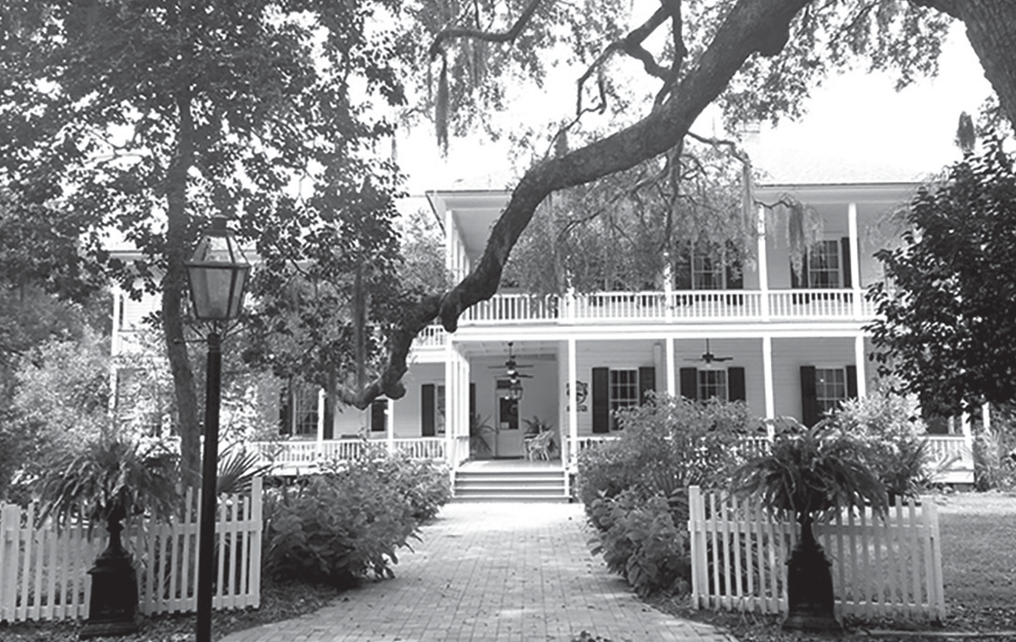

**EVENT SPOTLIGHT:**

**New! Swift-Coles Historic Home Tour\***

Originally built in 1882 by Thomas Gavin as a 4-room cabin, in 1898 Charles and Susan Swift purchased the cabin and moved in with their

eight children two years later. As the family grew they added the west wing, and by 1910, the entire upstairs—making it a total of 6000 square foot home with 3000-square-feet of porches. Nik Coles bought the home in 1976 and during his many years in residence filled it with numerous antiques from around the world. Before his death in 2007, he bequeathed the home to the Baldwin County Historic Development Commission. The home is now listed on the National Register of Historic Places and is a non-profit organization. After the tour, we will meet at The Tin Top Restaurant and Oyster Bar for a (Dutch-treat) lunch. *\*Not available on the all-inclusive Unlimited Classes option.*

**16-Mar | Mon 11:00 AM - 12:15 PM | $15**

Swift-Coles Historic Home

Instructor: Stephanie McNeill, MPS Florida Public Archaeology Network

Indian Temple Mound Museum*

Visit the Indian Temple Mound Museum, Camp Walton School Museum, Garnier Post Office and Civil War exhibit. Now preserved by the City of Fort Walton Beach, the mound is 17 feet tall and 223 feet long across the base. Built 1,000 years ago, it was the centerpiece

of Fort Walton Culture located in the heart of what is now downtown Fort Walton Beach. Afterward, we’ll have (Dutch-treat) lunch nearby — location to be determined. *\*Not available on the all-inclusive Unlimited Classes option.*

**6-Apr | Mon 10:30 AM - 12:00 PM | $15**

Indian Temple Mound

Make a Difference: Volunteer

Retirement is great! But what happens when you wake up to a blank calendar every morning? You can stay on the couch or watch television, but itís important for seniors to stay active and engaged with others to avoid boredom and social isolation. With volunteering, not only do you give back to the community, but an added bonus is it improves mental health, physical health and an enhanced sense of purpose. Come learn how to pick the right volunteer job for you and where to find positions. You will leave the session with a “get started volunteering kit” making it easy to immediately “get involved.”

**13-Apr | Mon 10:00 AM - 11:15 AM | $12**

Instructor: Pam Davis

Florida Public Archaeology Network

Finding Peace Within: Mediation and Mindfulness for Seniors

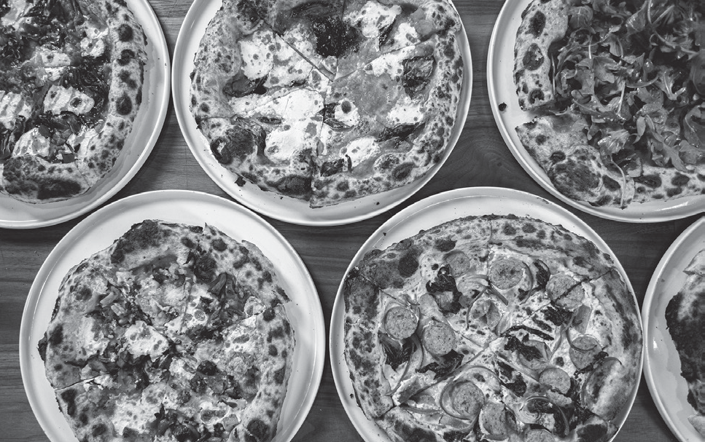

**EVENT SPOTLIGHT:**

**New! Angelena’s Restoranto Italiano**

The newest addition to the Merril family’s Great Southern Restaurant Group is Angelena’s, located in the Southtowne apartment complex and retail center in downtown Pensacola. The restaurant opened for dinner-only hours but is now serving lunch. Manager Jean Pierre N’Dione knows us from past visits to

Five Sisters Restaurant and he is eager to talk with us about this new location. Food Network personality and award-winning chef, James Brescioni, will also speak and answer questions for us. We will gather at the rustic yet elegant restaurant at 10:00 a.m. to enjoy free coffee and tea while we are welcomed by Lauren Smith, events manager, who will also introduce our speakers. Order off the menu and pay individually for your meal. If you sign up for the class you are expected to participate in lunch so only join if you plan accordingly. The restaurant will stamp your ticket and your parking will be free if you park in the Southtowne Complex underground garage.

**4-Feb | Tue 10:00 AM - 12:00 PM | $12**

Instructor: Lauren Smith Angelena’s Restoranto Italiano

In today’s world of future shock, information overload and data smog, finding inner peace can be more challenging than ever. Drawing on his No. 1 bestselling book, “Peace Within: Clear Your Mind, Open Your Heart, Embrace Your Soul and Heal Your

Life” and more than 30 years experience helping guide others on their life journeys, Michael will share his practices for finding more peace in today’s hectic, confusing world. He will also be performing some of his relaxation, healing music which has earned him four Grammy nominations.

**20-Apr | Mon 10:00 AM - 11:15 AM | $12**

Instructor: Michael DeMaria, Ph.D Studer Community Institute

**Tuesdays**

Hot Spot Barbecue

Enjoy lunch at Hot Spot Barbecue where the mouthwatering aroma can be detected up and down Ninth Ave. It is an unfussy outpost serving ample portions of smoked meats and delicious sides. We will gather at 10:15 a.m. in the private room for a talk then we will observe the cooking process outside before ordering our lunches off the menu. We will pay for our own lunches but Hot Spot will treat to coffee or tea, sweet tea and a cookie for dessert. The Hulbeks who own the restaurant are eager to share their knowledge and cooking methods and will be welcoming hosts for our visit.

**21-Jan | Tue 10:15 AM - 11:30 AM | $12**

Instructor: Cheri Hulbek Hot Spot Barbecue

New! Eden Energy Medicine

Energy medicine recognizes energy as a vital, living,

moving force that determines much about health and happiness. In Energy Medicine, energy is the

medicine, and energy is also the patient. You heal the body by activating its natural healing energies; you also heal the body by restoring energies that have become weak, disturbed or out of balance. Energy Medicine is both a complement to other medical care approaches and a complete system for self-care and self-help. It can help address physical illness and emotional or mental

disorders. It can also promote high-level wellness and peak performance. Join Susan Johnston in learning the basics of Eden Energy Medicine and Donna’s famous 5 - Minute Energy Routine. Put healing in good hands—your own!

**28-Jan | Tue 10:00 AM - 11:30 AM | $12**

Instructor: Susan Johnston

Florida Public Archaeology Network

New! Pensacola Museum of Art: John Markowitz

John Markowitz has been practicing art and teaching at UWF for years, and his talks to Leisure Learning have been most engaging. Now, he has an expansive show of his work at the PMA, and will talk with us about both the art and how he came to do it.

**28-Jan | Tue 2:00 PM - 3:30 PM | $12**

Instructor: John Markowitz Pensacola Museum of Art

Simple and Effective Art of EFT

**— Emotional Freedom Technique/ Tapping 1.0**

Learn the incredible technique of EFT/Tapping. Youíll

**Connect with us on Facebook!**

facebook.com/uwfleisurelearning

New! Simple and Effective Art of EFT (Part Two) 2.0

Now that you have the basics of Tapping from last semester's 1.0 class, this 2.0 course will delve deeper into developing your individual processes and protocols to utilize your new skills of Tapping fully. Some of the topics covered include: how to quickly and efficiently identify and understand your energy and distinguish it from others during any interaction; exercises and tools to help you continuously maintain your strength and

core power; the difference between the subconscious, the

probably agree that in this day and age when life runs on adrenaline, one needs to have reliable stress

management mechanisms in place. Self-help methods have become important life-skills. That is where Emotional Freedom Technique (EFT) or Tapping comes in. EFT is a fantastic self-help technique millions are using worldwide. Tapping can be used for relief from sadness, fear, worry, anxiety, anger, phobias, bad habits and performance issues naturally. You can use EFT for relief from negative emotions and a host of physical problems. Tapping is a newer term that is used to describe what is essentially EFT. It literally is a reset button at your fingertips.

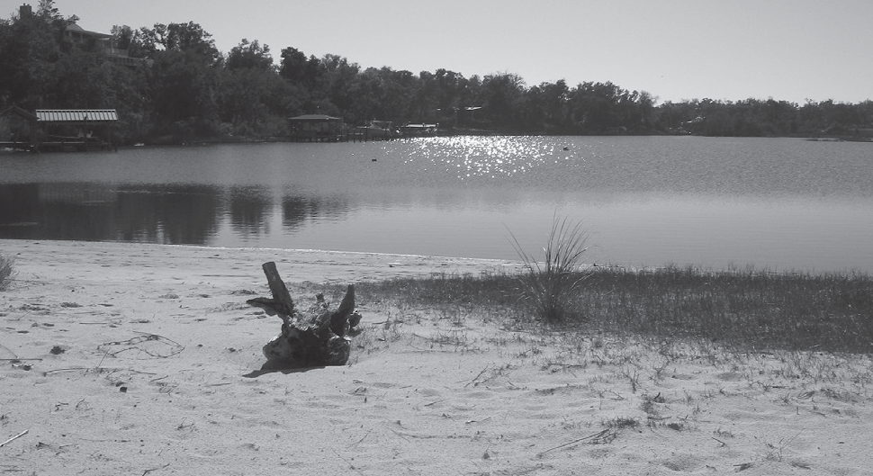

**EVENT SPOTLIGHT:**

**Deadman’s Island: Pensacola Bay’s Unique Landform**

Archaeologist Mike Thomin is a regular presenter in our Leisure Learning line-up. His knowledge and enthusiasm lure participants to his classes every semester. The area known as Deadman’s Island in Pensacola Bay has served as a careening ground, shipbuilding center, quarantine station and cemetery. Archaeologists have found the remains of extensive activities, both prehistoric and historic, ranging from shipwrecks to barrel wells to coffins. Learn about the unique geography of this interesting landform, and why people have used it for thousands of years.

**11-Feb | Tue 1:00 PM - 2:00 PM | $12**

Instructor: Mike Thomin

Florida Public Archaeology Network

**11-Feb | Tue 10:00 AM - 11:30 AM | $12**

Instructor: Susan Johnston

Florida Public Archaeology Network

New! Bodacious Chef:

**Nick Farcas\***

Join us in the demonstration kitchen of the Bocacious for a cooking demonstration with Chef Nick Farkas. Enjoy a tasty lunch of salad, pork loin, roasted zucchini and squash, skillet potatoes and a surprise

a la mode dessert while learning some knife skills and uses for olive oils and balsamic vinegars. Rishy Studer, Bodacious owner, has generously made this class possible for Leisure Learners and Chef Nick has

enthusiastically agreed to provide the experience. *\*Not available on the all-inclusive Unlimited Classes option.*

**18-Feb | Tue 11:00 AM - 1:00 PM | $25**

Instructor: Nick Farcas

Bodacious Shops So Gourmet Kitchen

conscious waking mind and the critical factor and how they affect our everyday lives; how we develop a belief system(s) and how they run our lives; how to quickly identify, breakthrough and positively change a belief system that no longer serves you; how to develop Tapping scripts whether general or to the point of an issue; and

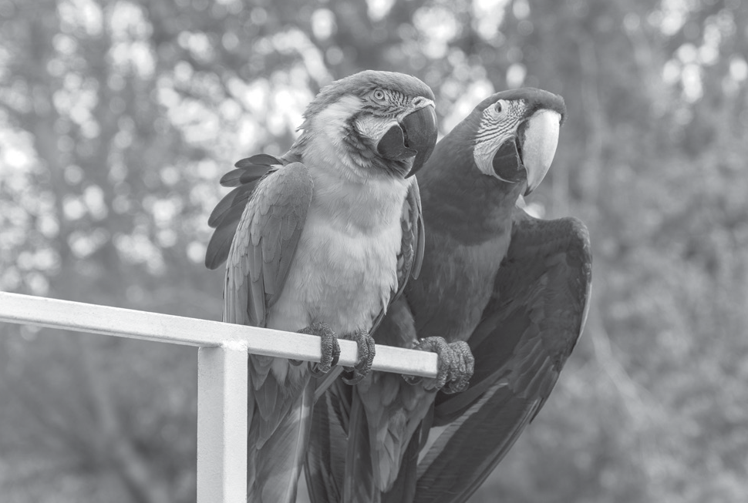

**EVENT SPOTLIGHT:**

**Uncle Sandy’s Macaw Bird Park\***

Come on out to one of the largest open flight aviaries in the area. A place to walk among the Macaws

and to view the many various species of wild birds, various species of parrots, emus, peacocks and even roaming chickens and their Mascot, Tom Turkey. The park is dedicated in Memorial to the founder, Sandy Carl Kirkonnell, otherwise known as Uncle Sandy. His love for Macaws and other wild birds started out as simply a “home” for his personal Macaws. Sandy provided sanctuary and comfort to not only his birds, but soon found a need for a place to take in unwanted birds. Through the help

of volunteers and close friends, Uncle Sandy’s legend has now become a non-profit organization that will continue providing a safe haven for the many exotic birds and other wildlife that make Uncle Sandy’s Macaw Bird Park home. Donations are welcome along with bird seed, parrot pellets and nuts. *Please note: Registration closes 3/9/2020. *Not available with the Unlimited Classes option.*

**10:00 AM - 11:30 AM | $15**

**Session #1: 17-Mar | Tue Session #2: 18-Mar | Wed** Macaw Bird Park

how to effectively learn to release and heal the old to allow the new.

**25-Feb | Tue 10:00 AM - 11:30 AM | $12**

Instructor: Susan Johnston

Florida Public Archaeology Network

New! Beginning Portrait Drawing*

**— 3 Sessions**

The focus of this class is to learn the fundamentals of drawing portraits. We will use pencil techniques to map the features of the face in both frontal and side views.

The second day, students are encouraged to bring a clear, self-photograph, or one of an acquaintance, preferably in a frontal view. No previous experience is required.*\* Not available with the Unlimited Classes option.*

**25-Feb & 26-Feb | Tue 1:00 PM - 3:00 PM | $25**

Instructor: Nannette Hammond Florida Public Archaeology Network

WEAR TV 3 Tour

This tour of Channel 3 WEAR-TV includes a visit to the Control Room and the Production Room. We will be in attendance while the 11:00 news, “Dayside with Sue Straughn,” is broadcast live. Walking and standing is

involved in the tour. *Sign up soon. Limited seating available!*

**10:30 AM - 11:30 AM | $12**

**Session #1: 3-Mar | Tue Session #2: 7-Apr | Tue** Instructor: Jack Canavan WEAR Channel 3

New! Executive Brain and Whole Person Lifestyling — 4 Sessions

Develop your executive brain and the wonders it can perform! Topics will include: finding your personal social involvement level; balancing security issues for increased mental health; learn how our fitness program includes improvement of all our body’s ten biological systems; and making leisure escape time part of your health plan.

**17-Mar to 7-Apr | Tue 1:00 PM - 2:15 PM | $25**

Instructor: Connie O’Connor

Florida Public Archaeology Network

Weeks Bay Reserve Pontoon Boat Tour*

Explore the natural beauty of Weeks Bay aboard the Weeks Bay Reserve Explorer! During this excursion, participants will learn about the ecology of the Weeks Bay

estuary while scouting for birds and other wildlife on the water. Learn about the rivers that feed this system as we travel up Magnolia River and discover some interesting historical tidbits about the area. We might even catch a glimpse of the mailman as he travels his mail route via boat. *\*Not available with the Unlimited Classes option.*

**10:00 AM - 12:00 PM | $25**

**Session #1: 24-Mar | Tue Session #2: 25-Mar | Wed** Instructor: Angela Underwood Weeks Bay Reserve

Planning for Long Term Care

This seminar will inform you of the emotional and financial impact a long-term event could have on your family, how

to plan so that the burden may be lessened and provide an explanation of why planning is so critical, especially for women. Learn about some actionable strategies for cash management/savings, asset allocation, diversification and portfolio rebalancing. Pat Broadus is dedicated to guiding those looking to retire and those already retired through a comprehensive retirement planning process, focusing on

long-term planning, risk and lifestyle review and retirement income needs. As a lifelong learner, he strongly believes in

**LUNCH ‘N’ LEARN EVENT:**

MEET THE ARTISTS OF

*IL TROVATORE*

**10-March | Tue 11:30 AM**

**New World Landing Banquet Hall | $30**

Verdi’s hot-blooded thriller emphasizes the “grand” in grand opera. The innocent Leonora is caught in a love triangle from which there is no escape. Pensacola Opera's Maestro Jerome Shannon and Education Director Cody Martin will give an overview of *Il Trovatore* and introduce the principal artists.

Excerpts from the upcoming production will be performed by Pensacola Opera's Artists in Residence.

***Invite your friends and family! Leisure Learning membership is not required to attend.***

**Reservations required in advance through March 3, 2020**.

*\*Not available on the all-inclusive Unlimited Classes option.*

the value of education. Pat is a veteran of the U.S. Army, holds a Bachelor’s degree in Economics from St. Bernard College and is a designated Chartered Retirement Planning Counselor and Retirement Income Certified Professional®.

**31-Mar | Tue 10:00 AM - 11:00 AM | $12**

Instructor: Patrick Broadus

Florida Public Archaeology Network

How Does Your Garden Grow?

Even if your name isn't “Mary,” come and join us for a lively discussion of your plant, turf, shrub, flower, tree and vegetable growth and maintenance issues. This class is open for discussion of all matters relating to horticulture in the Panhandle. You are invited to submit your questions for UF/IFAS analysis in advance of the class. Send your questions by email to Rhonda Robinson at rrobinson@ uwf.edu by Friday, Apr. 3, 2020. We will also tour the UF/ IFAS Educational Gardens containing border plantings, roses, herbs, evergreens, tropical and butterfly plant collections, ornamental grasses and more. Don’t forget your sunscreen or an umbrella in case of rain.

**14-Apr | Tue 2:00 PM - 3:15 PM | $12**

Instructor: Beth Bolles

Escambia County Extension Office

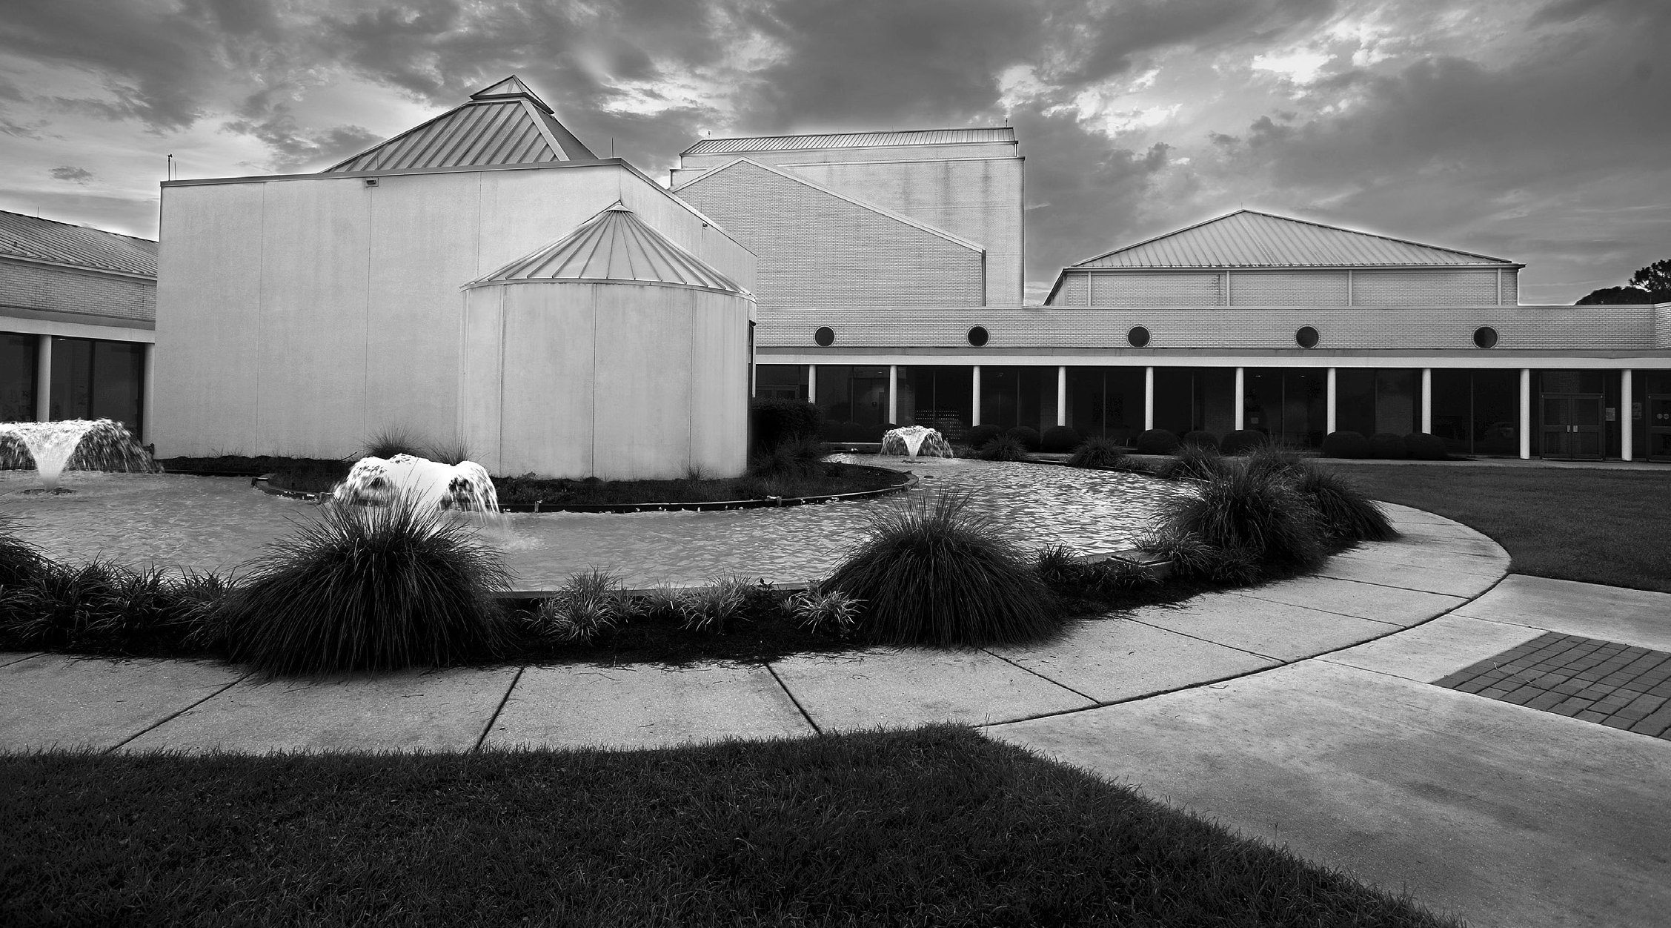

* Offering 100 events each year.
* Attracting 30,000 attendees
* $5 admission for Leisure Learners with Nautilus Card

**uwf.edu/cfpa**

Plan for your Future, Make it Happen

This class will provide a look at the advantages of a wealth management process and will show how utilizing a Life View Plan may help you to visualize your financial goals through wealth management. Pat Broadus is dedicated

to guiding both those looking to retire and those already retired through a comprehensive retirement planning process—focusing on long-term planning, risk and lifestyle review and retirement income needs. As a lifelong learner, he strongly believes in the value of education.

**21-Apr | Tue 10:00 AM - 11:00 AM | $12**

Instructor: Patrick Broadus

Florida Public Archaeology Network

New! Hangar Flying: Improvements in Aviation Safety

Despite recent tragic airline events, flying is often rated as the safest form of transportation. Fatal accidents have declined steadily since the 1950s. Safety has been the highest priority for the aviation industry for the past 100 years. Statistically, you have a greater chance of dying in an automobile or bicycle accident or from a lightning strike. What factors account for the dramatic improvements in aviation safety? What issues remain to be addressed? What further improvements in airline safety might we reasonably expect in the foreseeable

future? Join Bob Booth, career military and commercial pilot, to review the evolution of aviation safety, current issues and future developments in commercial air travel. Bring your questions regarding commercial air travel safety and security.

**21-Apr | Tue 1:30 PM - 3:00 PM | $12**

Instructor: Bob Booth

Florida Public Archaeology Network

##### Wednesdays

Communication Through Dance

Kym Atwood, a doctoral candidate at UWF and faculty associate in the Department of Movement Sciences and Health, will inform and entertain us with the subject

of dance. She will explain dance as an early form of communication and show us how it evolved throughout history including the roots of dance in Africa and its evolution as a social and cultural art form. We look forward to a little bit of demonstration and perhaps a bit of participation by willing class members. Plan to

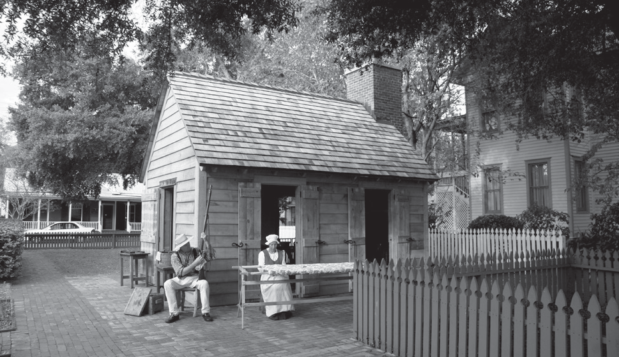

**EVENT SPOTLIGHT:**

**Historic Pensacola Village Tour\*** In 1970, the Seville Historic District in downtown Pensacola was designated as a U.S. Historic District.

Within the district is the Historic Pensacola Village. This collection of 29 historical buildings and museums is managed by the UWF Historic Trust. We will start our visit at 10:00 a.m. with a talk inside Old Christ Church on Seville Square. Guides will divide us into groups for the walking tour and visits to some of the buildings. Join us to learn about our historic city which had its beginnings in 1559. *\*Not available on the all-inclusive Unlimited Classes option.*

**15-Jan | Wed 10:00 AM - 11:30 AM | $15**

Old Christ Church

learn and enjoy as you are exposed to a unique class topic combined with valuable historic information.

**29-Jan | Wed 10:00 AM - 11:30 AM | $12**

Instructor: Kym Atwood

J. Earle Bowden Building #2

New! Great American Speech Series: Martin Luther King Jr.

Participants in the Fall 2018 offering reviewed the broad sweep of challenges facing human collective life. However, the greatest attention was given over to the essential tool human communities have to create effective responses to situations arising out of social life. Communication, that is to say language, is the formative instrument of public discourse which makes

possible coordinated social action. Using language (our linguistic instrument), we set about to remedy aspects of the human condition which require redress. Aspects or

problems of social living include areas as cultural conflict and abuse, contagion, poverty, the denial of basic human rights and the denial or limitation of access (for example, in housing, education, employment and healthcare).

Session one participants designated Racism for continued discussion in this ongoing series.

**29-Jan | Wed 1:00 PM - 3:00 PM | $12**

Instructor: Dr. Augusta Simon Florida Public Archaeology Network

Bodacious Shops — Wine and Cheese*

This class will be a repeat of the fall offering since there were more requests than spaces available.

Blake Howerton will teach about pairing wines with cheeses and we will sample the results. It will be a mouth-watering experience! Rishy Studer and her staff at the Bodacious Shops invite us back semester after semester and we are very grateful for the relationship. As usual a 10% discount will be offered to those Leisure

Learners who wish to shop after the class. *\*Not available on the all-inclusive Unlimited Classes option.*

**5-Feb | Wed 10:30 AM - 11:45 AM | $25**

Instructor: Blake Howerton

Bodacious Shops So Gourmet Kitchen

New! America’s Cup Challenge in Pensacola

The next America’s Cup sailboat race will be held in New Zealand in 2021, but the action is already heating up

as the challengers build and test their new boats. After many years of not participating, the New York Yacht Club is entering a challenge named American Magic and their team is practicing on Pensacola Bay. Come see videos of these new boats and discover how to watch them live from our own waterfront as they fly across the bay on their foils.

**12-Feb | Wed 9:30 AM - 11:15 AM | $12**

Instructor: David Hoffman

Florida Public Archaeology Network

**UWF Continuing Education | Spring 2020 Language and Culture Classes**



**Conversational Japanese I\***

Designed for beginners in Japanese skills and vocabulary.

**12-Feb to 8-Apr**

**Wed 6:30 PM - 7:30 PM | $80**

**Conversational Japanese III\***

Designed for people who have taken Conversational Japanese I and/

or II or are comfortable with basic Japanese language.

**30-Jan to 26-Mar**

**Thu 6:30 PM - 7:30 PM | $80**

**Korean Language Introductory I\***

Learn the fundamentals of Korean language, introductions, basic

vocabulary, basic grammar and the hangul writing system.

**Session #1: 15-Jan to 19-Feb Session #2: 26-Feb to 8-Apr Wed | 4:10 PM - 5:30 PM | $80**

**Korean Language II\***

Provides an introductory level of grammar and to increase vocabulary for daily life.

**14-Jan to 18-Feb**

**Tue 4:10 PM - 5:30 PM | $80**

**Korean Basic Conversation I\***

This class welcomes learners who want to enhance basic conversation skills.

**25-Feb to 7-Apr**

**Tue 4:10 PM - 5:30 PM | $80**

**To register, visit uwf.edu/continuinged/programs/personal-enrichment**

*\*Continuing Education Language and Culture Courses not included on the Unlimited Classes Option.*

**Want more information?**

Contact the Continuing Education Student Support Center at [continuinged@uwf.edu](mailto:continuinged@uwf.edu) or 850-473-7468.

New! Go Argos!: UWF Football with Florida Sports Hall of Famer Gordon Sprague

Perhaps it all started at FSU when Gordon Sprague met Judy Bense at the time FSU was struggling to build a football program. Gordon went on to become a motivational speaker, parks and recreation director,

businessman, philanthropist, antique car collector and a NASCAR driver. He also became a resident of Gulf Breeze and began close ties to UWF in 2008 when Judy Bense became the President. Although he goes back to the family farm in Vermont each summer, Gordon’s life here is very involved with UWF where he has been Chairman of the Football Founders Committee, Chair of the Foundation Board and an Inaugural Member of the Sword and Shield. Gordon has been honored by membership in the Florida Sports Hall of Fame. Gordon Sprague will give us the inside story of football on our campus and will answer questions we have about the program. He is eager to share his love for the game and for UWF.

**19-Feb | Wed 10:00 AM - 11:30 AM | $12**

Instructor: Gordon Sprague

J. Earle Bowden Building #1

New! Montessori Education 101

Maria Montessori was an educational pioneer and her unique approach has been educating children for more than 100 years. Join the Montessori School of Pensacola for a presentation on how such a historical figure was able to create a method of teaching that has stood the test of time and has proven benefits to many areas of development. See the approach in action—be prepared to be amazed at what young children can really do!

**26-Feb | Wed 10:00 AM - 11:30 AM | $12**

Instructor: Tricia Kruse

The Montessori School of Pensacola

Pensacola Yacht Club History

Formed in 1908, the Pensacola Yacht Club has been in the current clubhouse since 1947. Club members have been leaders in the community and the maritime scene for over a century. This organization has served

the community as a focal point for boating activities, a meeting place for civic and business leaders and the site of many beautiful weddings, celebrations and community events. This class includes a lecture and photo display of the club as it has progressed through 110 years and will be followed by a tour of the house and grounds. Lunch

can be purchased (Dutch-treat, credit card only) at the conclusion of the tour for those who would like to stay.

**4-Mar | Wed 10:00 AM - 11:30 AM | $12**

Instructor: David Hoffman Pensacola Yacht Club

Gulf Coast Citizen’s Diplomacy Council

The U.S. Department of State has a public diplomacy program where opinion-makers from across the globe travel the country to meet professionals and ordinary citizens of the USA. It’s called the International Visitor Leadership Program (IVLP). Jena oversees groups each year who visit Pensacola. For example, a group of search and rescue volunteers from the north woods of Russia came to see our S&R and Emergency Management operations. At the same time, Jena and her staff hosted a group of young women from a range of countries, here to examine technology and robotics and various aspects of engineering. Because part of the agenda is to meet and socialize with ordinary Americans, these groups often stay with host families. Join us to learn more about this great program.

**4-Mar | Wed 2:00 PM - 3:30 PM | $12**

Instructor: Jena Melancon

Florida Public Archaeology Network

**CLASS LISTINGS CONTINUED ON PAGE 21**

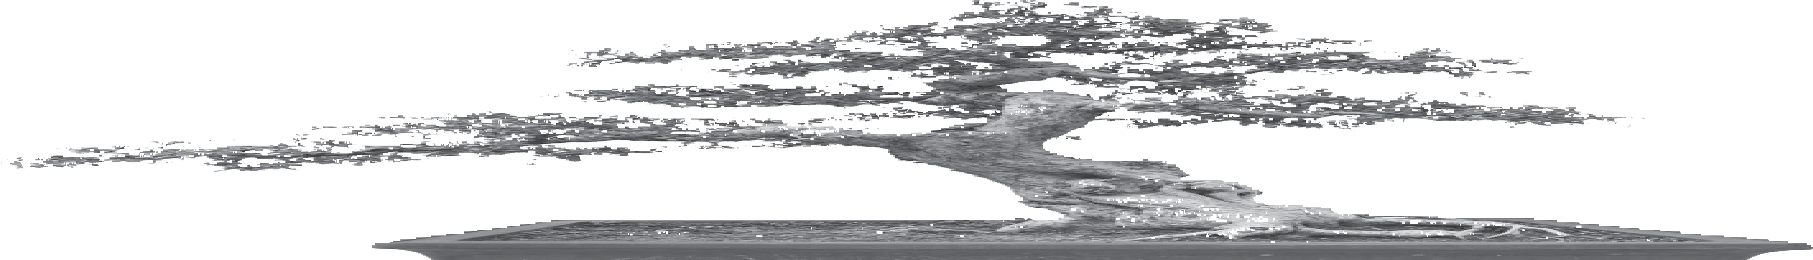

**EVENT SPOTLIGHT:**

**Keeping Bonsai Alive**

Learn about bonsai from Dr. Pierre Kaufke, a native of Alsace and a retired UWF professor. When not teaching French as an adjunct at PSC, Kaufke is pursuing his interest in bonsai. In 1975, at a Trappist Monastery in Conyers, Ga., his love of bonsai was born, and he is now developing his second marvelous collection. He will treat us to an interesting lecture and will demonstrate his skill with bonsai.

You will come away asking for a follow up class by this award- winning teacher.

**19-Feb | Wed**

**1:00 PM - 2:30 PM | $12**

Instructor:

Pierre Kaufke

J. Earle Bowden Building #1

**JANUARY 2020 — LEISURE LEARNING CLASS SCHEDULE**

**SUNDAY MONDAY TUESDAY WEDNESDAY THURSDAY FRIDAY SATURDAY**

|  |  |  |  |  |  |  |  |  |  |  |  |  |  |
| --- | --- | --- | --- | --- | --- | --- | --- | --- | --- | --- | --- | --- | --- |
|  | **29** | **30** | |  | **31** |  | **1** |  | **2** |  | **3** | **4** | |
|  | |  | |  | |  | |  | |
| **UWF CLOSED FOR WINTER BREAK**  December 23, 2019 - January 1, 2020 | | | | | | | |
|  | |  | | **New Year's Eve** | | **New Year's Day** | |
|  | **5** |  | **6** |  | **7** |  | **8** |  | **9** |  | **10** | **11** | |
|  | |  | |  | |  | |  | |  | |
|  | **12** |  | **13** |  | **14** |  | **15** |  | **16** |  | **17** | **18** | |
|  | | **10:00 AM - 11:15 AM**  Bodacious Bookstore  **1:00 PM - 2:15 PM**  Recorder Ensemble  **2:00 PM - 3:30 PM**  Calling All Bookies  **2:30 PM - 3:30 PM**  Learn to Play Recorder | | **11:30 AM**  **Lunch N' Learn Event:**  Meet the Artists of *Don Giovanni* | | **10:00 AM - 11:30 AM**  Historic Pensacola Village Tour | | **9:00 AM - 3:30 PM**  Bavarian’s Wirtshaus and Destin History and Fishing Museum | | **10:00 AM - 11:15 AM**  On the Other Hand... Current Affairs Discussions  **1:00 PM - 2:30 PM**  Illuminated Medieval Manuscripts and What They Reveal | |
|  | **19** | **20**  **Martin Luther King Jr. Day** | |  | **21** |  | **22** |  | **23** |  | **24** | **25** | |
|  | | **10:15 AM - 11:30 AM**  Hot Spot Barbecue | |  | | **1:00 PM - 2:30 PM**  Blue Wahoos Senior Writer: Bill Vilona | | **10:00 AM - 11:15 AM**  On the Other Hand... Current Affairs Discussions  **2:00 PM - 3:15 PM**  Anticipation 2020 | |
|  | **26** |  | **27** |  | **28** |  | **29** | **30**  **1:00 PM - 2:15 PM**  Pensacola Backyard Homestead | |  | **31** |  | **1** |
|  | | **1:00 PM - 2:15 PM**  Recorder Ensemble  **1:30 PM - 3:30 PM**  Quayside Art Gallery  **2:30 PM - 3:30 PM**  Learn to Play Recorder | | **10:00 AM - 11:30 AM**  Eden Energy Medicine  **2:00 PM - 3:30 PM**  Pensacola Museum of Art: John Markowitz | | **10:00 AM - 11:30 AM**  Communication Through Dance  **1:00 PM - 3:00 PM**  Great American Speech: Martin Luther King Jr. | | **10:00 AM - 11:15 AM**  On the Other Hand... Current Affairs  **1:00 PM - 2:15 PM**  The Rise of the Populist Middle  **2:00 PM - 3:15 PM**  Anticipation 2020 | |  | |

### FEBRUARY 2020 — LEISURE LEARNING CLASS SCHEDULE

**SUNDAY MONDAY TUESDAY WEDNESDAY THURSDAY FRIDAY SATURDAY**

|  |  |  |  |  |  |  |  |  |  |  |  |  |
| --- | --- | --- | --- | --- | --- | --- | --- | --- | --- | --- | --- | --- |
|  | **26** |  | **27** |  | **28** |  | **29** | **30**  **1:00 PM - 2:15 PM**  Pensacola Backyard Homestead | |  | **31** | **1** |
|  | | **1:00 PM - 2:15 PM**  Recorder Ensemble  **1:30 PM - 3:30 PM**  Quayside Art Gallery  **2:30 PM - 3:30 PM**  Learn to Play Recorder | | **10:00 AM - 11:30 AM**  Eden Energy Medicine  **2:00 PM - 3:30 PM**  Pensacola Museum of Art: John Markowitz | | **10:00 AM - 11:30 AM**  Communication Through Dance  **1:00 PM - 3:00 PM**  Great American Speech: Martin Luther King Jr. | | **10:00 AM - 11:15 AM**  On the Other Hand... Current Affairs  **1:00 PM - 2:15 PM**  The Rise of the Populist Middle  **2:00 PM - 3:15 PM**  Anticipation 2020 | |  |
|  | **2** |  | **3** |  | **4** |  | **5** |  | **6** |  | **7** | **8** |
|  | | **1:00 PM - 2:15 PM**  Chaos and Cartooning with Andy Marlette  **1:00 PM - 2:15 PM**  Recorder Ensemble  **2:30 PM - 3:30 PM**  Learn to Play Recorder | | **10:00 AM - 12:00 PM**  Angelena’s Restoranto Italiano | | **10:30 AM - 11:45 AM**  Bodacious Shops — Wine and Cheese | | **10:00 AM - 1:00 PM**  Scenic Highway Trolley Tour - #1 | | **10:00 AM - 11:15 AM**  On the Other Hand... Current Affairs Discussions  **2:00 PM - 3:15 PM**  Anticipation 2020 | |  |
|  | **9** |  | **10** |  | **11** |  | **12** |  | **13** |  | **14** | **15** |
|  | | **9:00 AM - 12:00 PM**  ECUA Facility Tour - #1  **1:00 PM - 2:15 PM**  Recorder Ensemble  **2:30 PM - 3:30 PM**  Learn to Play Recorder | | **10:00 AM - 11:30 AM**  Simple and Effective Art of EFT - Tapping 1.0  **1:00 PM - 2:00 PM**  Deadman’s Island | | **9:30 AM - 11:15 AM**  America’s Cup Challenge in Pensacola | | **3:00 PM - 4:00 PM**  W.R. Taylor Brick Company - #1 | | **10:00 AM - 11:15 AM**  On the Other Hand... Current Affairs Discussions  **1:00 PM - 2:30 PM**  Harmful Algal Blooms | |  |
|  | **16** |  | **17** |  | **18** |  | **19** | **20**  **9:30 AM - 12:00 PM**  McGuire’s Irish Pub & Brewery Tour - #1  **2:00 PM - 3:30 PM**  Supreme Court Preview | |  | **21** | **22** |
|  | | **1:00 PM - 2:15 PM**  Recorder Ensemble  **2:30 PM - 3:30 PM**  Learn to Play Recorder | | **11:00 AM - 1:00 PM**  Bodacious Chef: Nick Farcas | | **10:00 AM - 11:30 AM**  Go Argos!: UWF Football with Florida Sports Hall of Famer Gordon Sprague  **1:00 PM - 2:30 PM**  Keeping Bonsai Alive | | **10:00 AM - 11:15 AM**  On the Other Hand... Current Affairs Discussions  **1:00 PM - 2:30 PM**  What Ever Happened to Free Speech? | |  |
|  | **23** |  | **24** |  | **25** |  | **26** |  | **27** |  | **28** | **29** |
|  | | **10:00 AM - 11:30 AM**  Gálvez!  **1:00 PM - 2:15 PM**  Recorder Ensemble  **2:30 PM - 3:30 PM**  Learn to Play Recorder  **2:30 PM - 4:00 PM**  Laughter and Leading | | **10:00 AM - 11:30 AM**  Simple and Effective Art of EFT 2.0  **1:00 PM - 3:00 PM**  Beginning Portrait Drawing | | **10:00 AM - 11:30 AM**  Montessori Education 101  **1:00 PM - 3:00 PM**  Beginning Portrait Drawing | | **3:00 PM - 4:00 PM**  W.R. Taylor Brick Company - #2 | | **10:00 AM - 11:15 AM**  On the Other Hand... Current Affairs Discussions  **1:00 PM - 2:30 PM**  What Ever Happened to Free Speech | |  |

### MARCH 2020 — LEISURE LEARNING CLASS SCHEDULE

**SUNDAY MONDAY TUESDAY WEDNESDAY THURSDAY FRIDAY SATURDAY**

|  |  |  |  |  |  |  |  |  |  |  |  |  |  |
| --- | --- | --- | --- | --- | --- | --- | --- | --- | --- | --- | --- | --- | --- |
|  | **1** |  | **2** |  | **3** |  | **4** |  | **5** |  | **6** |  | **7** |
|  | | **1:00 PM - 2:15 PM**  St. Michael’s Cemetery  **1:00 PM - 2:15 PM**  Recorder Ensemble  **2:30 PM - 3:30 PM**  Learn to Play Recorder | | **10:30 AM - 11:30 AM**  WEAR TV 3 Tour - #1 | | **10:00 AM - 11:30 AM**  Pensacola Yacht Club  **2:00 PM - 3:30 PM**  Gulf Coast Citizen’s Diplomacy Council | | **10:00 AM - 1:00 PM**  Scenic Highway Trolley Tour - #2 | | **10:00 AM - 11:15 AM**  On the Other Hand... Current Affairs Discussions  **1:00 PM - 2:30 PM**  What Ever Happened to Free Speech | |  | |
|  | **8** |  | **9** |  | **10** |  | **11** |  | **12** |  | **13** |  | **14** |
|  | | **10:00 AM - 11:15 AM**  Voluntary Exile...  **1:00 PM - 2:15 PM**  Recorder Ensemble  **1:00 PM - 2:30 PM**  UWF Archives: Art  **2:30 PM - 3:30 PM**  Learn to Play Recorder | | **11:30 AM**  **Lunch N' Learn Event:**  Meet the Artists of *Il Trovatore* | | **10:00 AM - 12:30 PM**  Storybook Castles and Fairhope Museum - #1  **1:00 PM - 2:30 PM**  UWF Archives: Presidents  **2:00 PM - 4:30 PM**  Storybook Castles and Fairhope Museum - #2 | | **10:30 AM - 11:45 AM**  Bocce Ball for All  **1:00 PM - 2:00 PM**  Tales of the Maya Skies: Pensacola State College Planetarium | | **1:30 PM - 3:00 PM**  How Did Artists Gain Perspective? | |  | |
|  | **15** |  | **16** |  | **17** |  | **18** |  | **19** | **20** | |  | **21** |
|  | | **9:00 AM - 12:00 PM**  ECUA Facility Tour - #2  **11:00 AM - 12:15 PM**  Swift-Coles Home Tour | | **10:00 AM - 11:30 AM**  Uncle Sandy’s Macaw Bird Park - #1  **1:00 PM - 2:15 PM**  Executive Brain and Whole Person Lifestyling | | **10:00 AM - 11:30 AM**  Uncle Sandy’s Macaw Bird Park - #2  **10:00 AM - 12:00 PM**  Charcoal Drawing  **2:00 PM - 3:15 PM**  Stonewall Jackson’s Shenandoah Valley Campaign | | **10:30 AM - 11:45 AM**  Bocce Ball for All  **1:00 PM - 3:00 PM**  Humming Star Alpacas | | **1:00 PM - 2:30 PM**  Florida’s Current Economic and Legislative Outlook | |  | |
| **1:00 PM - 2:15 PM**  Recorder Ensemble | |  | |  | |
| **2:30 PM - 3:30 PM**  Learn to Play Recorder | |  | |  | |
|  | **22** |  | **23** |  | **24** |  | **25** |  | **26** |  | **27** |  | **28** |
|  | | **10:00 AM - 11:30 AM**  Voices of the American Spirit: Willa Cather  **1:00 PM - 2:15 PM**  Recorder Ensemble  **2:30 PM - 3:30 PM**  Learn to Play Recorder | | **10:00 AM - 12:00 PM**  Weeks Bay Reserve Pontoon Boat Tour - #1  **1:00 PM - 2:15 PM**  Executive Brain and Whole Person Lifestyling | | **10:00 AM - 12:00 PM**  Weeks Bay Reserve Pontoon Boat Tour - #2  **1:00 PM - 3:00 PM**  Roy Hyatt Environmental Center Tour - #1 | | **10:30 AM - 11:45 AM**  Bocce Ball for All  **1:00 PM - 2:30 PM**  Tax-Free Investing | | **12:00 PM - 2:45 PM**  Historic Oakleigh House and Mobile Carnival Museum | |  | |
|  | **29** | **30**  **10:00 AM - 11:30 AM**  Voices of the American Spirit: Willa Cather  **1:00 PM - 2:15 PM**  Recorder Ensemble  **2:30 PM - 3:30 PM**  Learn to Play Recorder | |  | **31** |  | **1** |  | **2** |  | **3** | **4** | |
|  | | **10:00 AM - 11:00 AM**  Planning for Long Term Care  **1:00 PM - 2:15 PM**  Executive Brain and Whole Person Lifestyling | | **10:00 AM - 11:30 AM**  Divine Life Lessons  **1:00 PM - 3:00 PM**  Roy Hyatt Environmental Center Tour - #2 | | **10:00 AM - 1:00 PM**  Scenic Highway Trolley Tour - #3  **10:30 AM - 11:45 AM**  Bocce Ball for All | | **2:30 PM - 4:00 PM**  Topics in Contemporary Political Science | |  | |

### APRIL 2020 — LEISURE LEARNING CLASS SCHEDULE

**SUNDAY MONDAY TUESDAY WEDNESDAY THURSDAY FRIDAY SATURDAY**

|  |  |  |  |  |  |  |  |  |  |  |  |  |  |
| --- | --- | --- | --- | --- | --- | --- | --- | --- | --- | --- | --- | --- | --- |
|  | **29** | **30**  **10:00 AM - 11:30 AM**  Voices of the American Spirit: Willa Cather  **1:00 PM - 2:15 PM**  Recorder Ensemble  **2:30 PM - 3:30 PM**  Learn to Play Recorder | |  | **31** |  | **1** |  | **2** |  | **3** | **4** | |
|  | | **10:00 AM - 11:00 AM**  Planning for Long Term Care  **1:00 PM - 2:15 PM**  Executive Brain and Whole Person Lifestyling | | **10:00 AM - 11:30 AM**  Divine Life Lessons  **1:00 PM - 3:00 PM**  Roy Hyatt Environmental Center Tour - #2 | | **10:00 AM - 1:00 PM**  Scenic Highway Trolley Tour - #3  **10:30 AM - 11:45 AM**  Bocce Ball for All | | **2:30 PM - 4:00 PM**  Topics in Contemporary Political Science | |  | |
|  | **5** |  | **6** |  | **7** |  | **8** |  | **9** |  | **10** | **11** | |
|  | | **10:30 AM - 12:00 PM**  Indian Temple Mound | | **10:30 AM - 11:30 AM**  WEAR TV 3 Tour - #2 | | **10:00 AM - 11:30 AM**  Divine Life Lessons | | **10:30 AM - 11:45 AM**  Bocce Ball for All | |  | |  | |
| **1:00 PM - 2:15 PM**  Recorder Ensemble  **2:30 PM - 3:30 PM**  Learn to Play Recorder | | **1:00 PM - 2:15 PM**  Executive Brain and Whole Person Lifestyling | |  | | **1:30 PM - 3:00 PM**  New! Hangar Flying: Where are We? | |  | |
|  | **12** |  | **13** |  | **14** |  | **15** |  | **16** |  | **17** | **18** | |
|  | | **10:00 AM - 11:15 AM**  Make a Difference: Volunteer  **1:00 PM - 2:15 PM**  Recorder Ensemble  **2:30 PM - 3:30 PM**  Learn to Play Recorder | | **2:00 PM - 3:15 PM**  How Does Your Garden Grow? | | **10:00 AM - 11:30 AM**  Divine Life Lessons: Uncovering Your Sacred Self  **10:00 AM - 12:00 PM**  Conte Crayon Drawing with Larry Manning | | **10:00 AM - 11:15 AM**  Healthy Living for Your Brain and Body: Tips from the Latest Research  **1:00 PM - 3:30 PM**  Create-a-Craft: Sea Angels | |  | |  | |
|  | **19** | **20** | |  | **21** |  | **22** |  | **23** |  | **24** | **25** | |
|  | | **10:00 AM - 11:15 AM**  Finding Peace Within: Mediation and Mindfulness for Seniors  **1:00 PM - 2:15 PM**  Recorder Ensemble  **2:30 PM - 3:30 PM**  Learn to Play Recorder | | **10:00 AM - 11:00 AM**  Plan for your Future, Make it Happen  **1:30 PM - 3:00 PM**  New! Hangar Flying: Improvements in Aviation Safety | | **10:00 AM - 11:30 AM**  Divine Life Lessons: Uncovering Your Sacred Self | | **9:30 AM - 12:00 PM**  McGuire’s Irish Pub & Brewery Tour - #2  **1:00 PM - 2:30 PM**  Richmond: Primary Arms Producer  for the South | |  | |  | |
|  | **26** |  | **27** |  | **28** |  | **29** | **30** | |  | **1** |  | **2** |
|  | | **1:00 PM - 2:15 PM**  Recorder Ensemble (cont. until May 18)  **2:30 PM - 3:30 PM**  Learn to Play Recorder (cont. until May 18) | |  | |  | |  | |  | |

### CLASSES

Storybook Castles and Fairhope History Museum*

Joined together by family legacy and limitless imagination, the Sheldon and Mosher Castles are a testament to ingenuity, resourcefulness, creativity and beauty. Dean and Pagan Mosher presently reside in the Mosher Castle. Pagan’s father and legendary artist and sculptor, Craig Sheldon began this magical, one-of-a-kind treasure more than 60 years ago. Mr. Sheldon recycled, reused and repurposed everything he could salvage. Dean Mosher has fervently continued Sheldon’s work, and

so, the Mosher Castle continues to grow. The Fairhope History Museum features changing exhibits on the mezzanine as well as permanent displays of Fairhopeís unique history. There is a larger than life bronze sculpture of Craig Sheldon and a collection of his wood carvings.

The museum also boasts Dean Mosher’s artwork, “The Founders of Fairhope.” To learn more about Dean, visit [www.deanmosher.com.](http://www.deanmosher.com/) We will begin with a presentation and guided tour of the castles with Dean Mosher, afterward we will meet at the Fairhope History Museum for a guided tour by museum director, Allan Samry.

art and fun meet! Local artist Larry Manning will demonstrate how to create a beautiful one-of-a-kind charcoal drawing masterpiece. This session will be a contemporary non-objective study which would explore value, texture and shape. You will be given other creative ideas so that everyone’s picture will be uniquely different. Please bring either an apron or an old shirt.

Paper, charcoal and art supplies are provided. *Please note: Registration closes 3/10/2020. *Not available on the all-inclusive Unlimited Classes option.*

**18-Mar | Wed 10:00 AM - 12:00 PM | $30**

Instructor: Larry Manning

J. Earle Bowden Building #1

New! Stonewall Jackson’s Shenandoah Valley Campaign of 1862

Join local author, James H. Donnell (Lt. Col., USAF, Ret.) as he shares about his book, “Shenandoah Valley 1862,” which was published in 2013. Donnell’s fascination with American History continued on and

he published a second book, “Atlanta 1864,” three years

*Please note: Registration closes 3/2/2020. *Not available on the all-inclusive Unlimited Classes option.*

**11-Mar | Wed | $15**

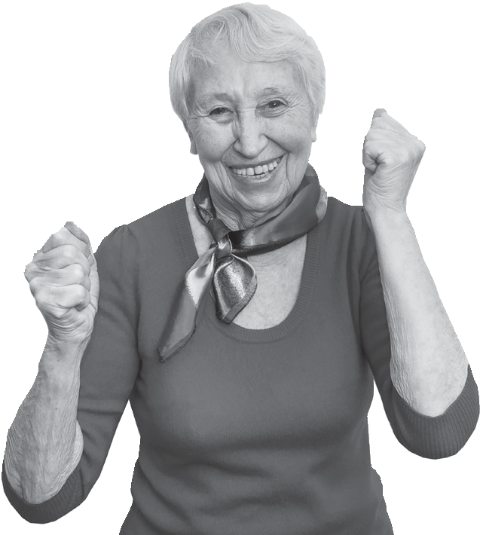

**Unlimited Classes Discount**

**During the Fall and Spring semesters, take unlimited classes for only $180 per semester!**

This option is available by completing the registration form in the catalog and mailing a check or calling the Leisure Learning office at 850.473.7468 to pay by credit card. Some classes are not eligible for this offer and are

marked in this catalog with an asterisk beside the class title.

**Because of possible schedule or location changes, advance registration is highly recommended for**

**ALL classes.**

*Please note: Individual class fee refunds are not available for the unlimited class option if you are unable to attend OR if the*

*class is canceled.*

**Session #1: 10:00 AM - 12:30 PM**

**Session #2: 2:00 PM - 4:30 PM**

Fairhope Museum of History & Dean Mosher Studio

UWF Archives & West Florida Center John C. Pace Library Tour: The American Presidents

***Pre-registration required***

Along with our tour of the far reaches of the Archives, we'll take you on a journey of the American Presidency, highlighting manuscripts and other materials in the collections associated with the

White House and its occupants. This class is free and available to Leisure Learning members only. *Space is limited, pre-registration is required.*

**11-Mar | Wed 1:00 PM - 2:30 PM | $0**

Instructor: Dean DeBolt

UWF John C. Pace Library UWF Archives & West Florida History Center, Basement

Charcoal Drawing with Larry Manning*

Add some creativity to your day while discovering where

**CONTINUED FROM PAGE 16**

later. In this session, learn about what happened in the spring of 1862, the Shenandoah Valley of western Virginia which was the scene of some of the fiercest fighting of the Civil War. Marching over 600 miles in 48 days, Jackson’s army won five major battles,

constantly outmaneuvering a Union army that, at times, outnumbered his troops 3 to 1.

**18-Mar | Wed 2:00 PM - 3:15 PM | $12**

Instructor: James Donnell

Florida Public Archaeology Network

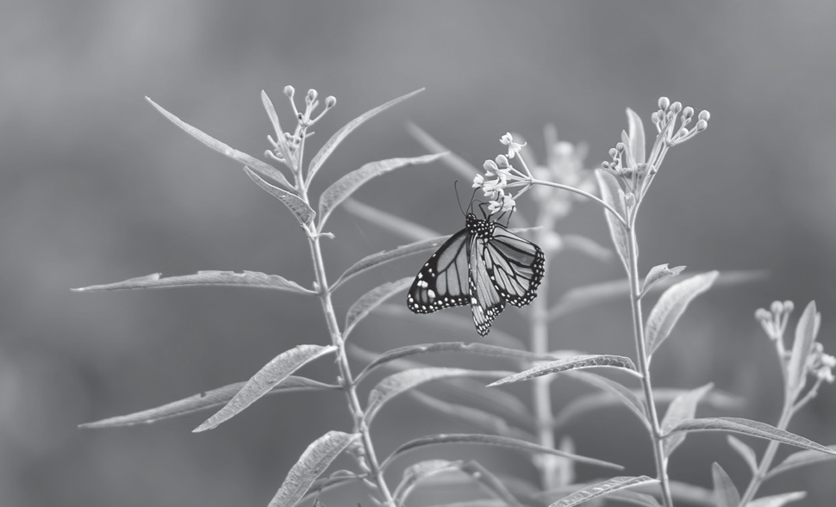

**EVENT SPOTLIGHT:**

**Roy Hyatt Environmental Center Tour**

The Roy Hyatt Environmental Center is located on 120 acres of upland pine forest and seepage bog.

While here you will tour the new facility, opened in September 2019, including the microscope lab, the reptile room and more. You will also have the opportunity to board the bird watching bus and observe birds feeding and splashing in the bird pond. Then we will tour the butterfly garden and walk one of the many trails searching for native flora and fauna, finally reaching the seepage bog where we will see several species of carnivorous plants including the endangered white-topped pitcher plant.

**Wed 1:00 PM - 3:00 PM | $12**

**Session #1: 25-Mar**

**Session #2: 1-Apr**

Instructor: Molly O’Connor

Roy Hyatt Environmental Center

New! Divine Life Lessons: Uncovering Your Sacred Self — 4 Sessions

In this class we will uncover and explore identity, insight and boundaries. How we learn through our patterns and memories and how to positively use these patterns to enhance our lives. Find out why specific patterns continue to repeat themselves and how to break the cycle if you are experiencing negative results. Learn healthy boundaries— how to create one, how “vibrational markers/blocked energy” are created, and how to release, clear and heal negative vibrations, allowing you to move into a positive, healthier and happy life. We will discuss how to identify and break the chains and heal generational cycles of dysfunction and how to quickly and easily identify when you are “leaking energy” and stepping out of your power. You will develop your own boundary language—where you are feeling grounded, calm empowered and learn how to significantly enhance all of your relationships through your own healthy insight and personal power.

**1-Apr to 22-Apr | Wed 10:00 AM - 11:30 AM | $25**

Instructor: Susan Johnston Downtown Pensacola TBD

New! Conte Crayon Drawing with Larry Manning*

Add some creativity to your day while discovering where art and fun meet! Local artist Larry Manning will demonstrate how to create a beautiful one-of-a-kind sepia conte crayon drawing masterpiece. This session will focus on a study in line while using a still-life display. You will be given other creative ideas so that everyone’s picture will be uniquely different. Please bring either an apron

or an old shirt. Paper, conte crayons and art supplies are provided. *Please note: Registration closes 4/7/2020. *Not available on the all-inclusive Unlimited Classes option.*

**15-Apr | Wed 10:00 AM - 12:00 PM | $30**

Instructor: Larry Manning

J. Earle Bowden Building #1

**Thursdays**

Bavarian’s Wirtshaus and Destin History & Fishing Museum*

The Destin History and Fishing Museum exhibits present the history of Destin and its journey from a small fishing village to a major tourist attraction. We will have a

guided tour of the 5,500-square-foot museum to include an overview in the Rodeo Gallery, the early Indians, over 75 mounts of locally caught fish and the science

of “Why Destin Sand is White.” After a bus ride to our first destination, we will begin our day at the Bavarian Wirtshaus, a new German Restaurant at 10:30 a.m. in Fort Walton Beach for a talk with the German chefs who will share information about German food. The atmosphere

is very Bavarian, the food is authentic and the owners are very enthusiastic about having our group. We will order off the menu and pay individually for our meals. Next, the bus will take us to the small charming museum in Destin where Kathy Blue, UWF alum and retired teacher, will give us a tour and share the beginnings of Destin and the changes through the years. There is much to learn in this tiny building filled with history. Please Note: Class fee includes transportation and museum entry fee. We

are offering two pickup locations: Cordova Mall, Dick’s Sporting Goods parking lot at 9:00 a.m. and Walmart at Tiger Point in Gulf Breeze at 9:25 a.m. *\*Not available on the all-inclusive Unlimited Classes option.*

**16-Jan | Thu 9:00 AM - 3:30 PM | $55**

Bavarian’s Wirtshaus and Destin History & Fishing Museum

**Connect with us on Facebook!**

facebook.com/uwfleisurelearning

New! Blue Wahoos Senior Writer: Bill Vilona

For 32 years, Bill Vilona was a sports writer for the Pensacola News Journal before he retired and went to work for Studer 55 Communications and the Blue Wahoos. Everyone in this community who knows sports, knows Bill, a member of the Pensacola Sports Hall of Fame and the UWF Athletic Hall of Fame. He has so much to share about his illustrious career which includes covering the 1994 World Cup in Orlando and the 1996 Olympics in Atlanta as well as a Super Bowl and five Masters’ Tournaments. Bill will share his experiences and answer questions while inspiring us with stories like his interview with Bear Bryant back in his days at the University of Tennessee. Bill is an esteemed member of our community who was pleased to accept this course invitation as another way to participate in community service.

**23-Jan | Thu 1:00 PM - 2:30 PM | $12**

Instructor: Bill Vilona

Florida Public Archaeology Network

**Advocate for Leisure Learning**



Retirement can be rewarding with participation in programs like Leisure Learning, which fosters educational enrichment and growth.

Gifts to UWF Leisure Learning are an important factor in enhancing the educational experience for our members.

Your generous support guarantees that we can continue to offer a superb quality programing at an unmatched value.

**Please put Leisure Learning on your charitable giving list. Make your gift today. Your classmates are counting on you!**

*Please make checks payable to:*

**UWF Foundation - Leisure Learning 11000 University Pkwy.**

**Building 12, Pensacola, FL 32514**

*Thank you from all of us at UWF Continuing Education and the*

*more than 350 Leisure Learning members we serve annually.*

**Leisure Learning** is a program of UWF Continuing Education, a premier regional provider of high-quality credit and non-credit courses, community programming, customized training, CEUs and conference planning. **uwf.edu/continuinged**

**Pensacola Backyard Homestead**

Renée Perry and Tom Garner of East Hill Edible Gardening take you on a first-hand look at the fascinating and infinitely practical world of backyard homesteading. Also known as urban farming, backyard homesteading produces the freshest, healthiest, local food in a residential setting. Learn how Renée and Tom raise food on their own quarter acre residential lot, including fruits, vegetables, eggs, honey and more. You will be amazed at how much food you can grow in your own backyard! Bring your questions concerning Fall gardening opportunities and challenges in the Panhandle. Tom and Renée are past leaders of the Pensacola Organic Gardening Club.

**30-Jan | Thu 1:00 PM - 2:15 PM | $12**

Instructor: Renée Perry

Florida Public Archaeology Network

Scenic Highway Trolley Tour*

Amateur historian and Scenic Highway Foundation member Robin Rowan will be your guide on this fun and informative tour of one of Florida’s most beautiful scenic highways. Learn about America’s

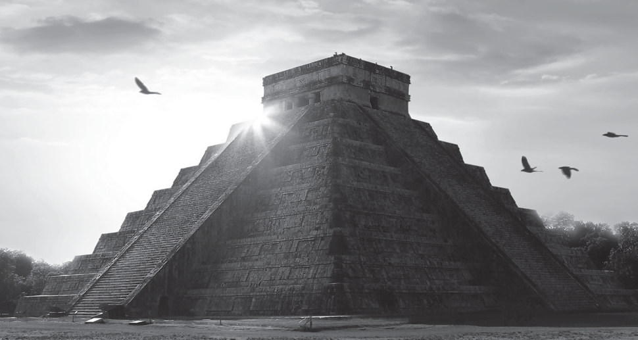

**EVENT SPOTLIGHT:**

**Tales of the Maya Skies: Pensacola State College Planetarium\***

Immerse yourself in the beauty of the “seventh wonder of the modern world,” Mexico’s Chichén Itzá. Experience a new digital full-dome planetarium show, that will transport you to the jungles of Mexico and showcase the rich history and culture of the ancient Maya. Using the latest three-dimension- al laser scanning and advanced graphic techniques, *Tales of the Maya Skies* weaves together the richness of Maya culture, stories and science. The show will be followed by an additional short presentation

of the night sky of that day. *\*Not available on the all-inclusive Unlimited Classes option.*

**12-Mar | Thu 1:00 PM - 2:00 PM | $15**

Pensacola State College Planetarium, Bldg 21

oldest neighborhood, where Don Tristan de Luna and 1500 colonists disembarked along the high bluffs in East Pensacola Heights in 1559 to claim West Florida for Spain. The tour will also share information about how Magnolia Bluffs Park (now Bay Bluffs Park) was established for railroad workers in 1883 and Gull Point where Marianna Bonifay and one of her sons grew oranges, while a bit farther north other early settlers tried their hand at silk and wine! And yes, there really was a ferry boat at Ferry Pass before a bridge was built, taking tourists over to the new hot spot in Santa Rosa County—Mulat! The group will park at Brew Ha Ha restaurant on 12th Ave., board the Go Retro shuttle at 10 a.m. and return to Brew Ha Ha for (Dutch-Treat) lunch following the tour. *\*Not available on the*

*all-inclusive Unlimited Classes option.*

**Thu 10:00 AM - 1:00 PM | $25**

**Session #1: 6-Feb**

**Session #2: 5-Mar**

**Session #3: 2-Apr** Instructor: Robin Rowan Brew Ha Ha

**New! W.R. Taylor Brick Company** Originally a stable trading in horses, mules, harnesses, hay, feed and wagons, this more than 100-year-old building now houses a state of the art brick studio. The space we will visit is small, so we are offering two sections of this class in which Hayden Ward, division manager, will inform us about this important Pensacola industry.

The water powered elevator will be on our tour and the historians in our group will probably ask about the days when it was powered by the creek that runs under St. Michael’s Cemetery. This will be an interesting and

unique class held in a building where probably no Leisure Learners have ever been.

**Thu 3:00 PM - 4:00 PM | $15**

**Session #1: 13-Feb**

**Session #2: 27-Feb**

Instructor: Hayden Ward

W.R. Taylor Brick Company

McGuire’s Irish Pub & Brewery Tour

McGuire’s Irish Pub first opened in 1977 in a shopping

center as a small neighborhood pub. In 1982, McGuire’s moved to its current location which was Pensacola’s original 1927 Old Firehouse. Inside the pub you’ll find a turn-of-the-century New York Irish Saloon themed restaurant. Learn about all the fun things that go on there, how much money is tacked to the ceiling, how the wonderful beer is made in huge copper vats and information about the wine collection. Our genial host,

Perry, will answer your questions. After the tour, you will be seated for a (Dutch treat) lunch. *Sign up soon—limited seating available!*

**Thu 9:30 AM - 12:00 PM | $12**

**Session #1: 20-Feb**

**Session #2: 23-Apr** Instructor: Perry Hunter McGuire’s Irish Pub

Supreme Court Preview: Cases to Watch in the 2020-21 Term

Preview some important upcoming Fall 2020 court cases with Dr. David Ramsey. Bring your questions, there will be an opportunity for discussion. Dr Ramsey will review

the Court’s current and recent calendar and discuss pertinent ramifications of the cases and decisions. No knowledge of the law is needed—this course is intended to be for a general audience.

**20-Feb | Thu 2:00 PM - 3:30 PM | $12**

Instructor: Dr. David Ramsey

J. Earle Bowden Building #2

Humming Star Alpacas*

Humming Star Alpacas is a small, quaint alpaca farm where alpacas are raised for their amazing fleece. Learn all about the alpacas; their homeland, behavior, anatomy, nutritional needs and their fleece. After watching a short video of the alpacas being sheared for an understanding of the method of harvesting the fleece, we will then learn about the picker and carder (small instruments used to process the fleece). Attendees will each take home a fiber art piece.*\*Not available on the all-inclusive Unlimited Classes option.*

**19-Mar | Thu 1:00 PM - 3:00 PM | $15**

Instructor: Cheryl Bowen Humming Star Alpaca Farm



Tax-Free Investing: It’s Not What You Make, It’s What You Keep!

Concerned with the taxes you pay on investments? This presentation will give an overview of tax-advantaged investments and strategies that you can use!

**26-Mar | Thu 1:00 PM - 2:30 PM | $12**

Instructor: John Hodgdon II

Florida Public Archaeology Network

New! Hangar Flying:

**Where are We?**

Did you ever wonder how commercial airlines can take you from one location to another without getting lost? Flying at 35,000 feet above the earth? Through impenetrable cloud banks? Over vast oceans? Through blinding storms? Aviation navigation is the science and skill of piloting an aircraft from place to place

without getting lost. Join Bob Booth for an explanation and discussion aircraft navigation, past, present, and future. The class will describe route planning, in-flight navigation, navigation skills, systems and aids. Bring your compass (just kidding) and questions to the class.

**9-Apr | Thu 1:30 PM - 3:00 PM | $12**

Instructor: Bob Booth

Florida Public Archaeology Network

New! Healthy Living for Your Brain and Body: Tips from the Latest Research

For centuries, we’ve known that the health of the brain and the body are connected. But now, science is able to provide insights into how to make lifestyle choices that may help you keep your brain and body healthy as you age. Join us to learn about research in the areas of diet and nutrition, exercise, cognitive activity and social engagement, and use hands-on tools to help you incorporate these recommendations into a plan for healthy aging.

**16-Apr | Thu 10:00 AM - 11:15 AM | $12**

Instructor: Katie Fahrenbruch Florida Public Archaeology Network

New! Create-a-Craft: Sea Angels*

There are Guardian Angels and Christmas Angels, and then there are Sea Angels—special creations from shells that are perfect for birthday gifts and any other memorable occasion. This class focuses on selecting and constructing angels from both scallop and oyster

shells. You’ll learn how to pick out “wings” and “heads” of proportionate size and shape; how to embellish

with ribbons, beads and other shells; and how to make attachments for hanging. Bring your glue gun, glue sticks and scissors. The shells and other supplies are provided.



**Discover more online!**

UWF Continuing Education offers a variety of 6-week online enrichment courses. From Drawing for the Absolute Beginner and Introduction to Guitar to Speed Spanish and Write and Publish Your Nonfiction Book, these online courses provide the flexibility to gain new skills on your own time.

**Visit https://**[**www.ed2go.com/uwf/**](http://www.ed2go.com/uwf/) **to browse the online course catalog.**

Join in on the fun and take some Sea Angels home with you! *Please note: Registration closes: 4/8/2020. *Not available on the all-inclusive Unlimited Classes option*.

**16-Apr | Thu 1:00 PM - 3:30 PM | $25**

Instructor: Rheta Kirk

Florida Public Archaeology Network

New! Richmond: Primary Arms Producer for the South

Richmond, Virginia was not only the Capital of the Confederacy, it also produced guns, bullets and shells large and small. The components of Richmond's arms production industry include the Tredegar Ironworks, Artillery as well as amour plating for ships; The Richmond Arsenal, Muskets; The Confederate States Laboratory Department, munitions. Their contributions would enable the Confederacy to arm its soldiers and conduct four bloody years of war.

**23-Apr | Thu 1:00 PM - 2:30 PM | $12**

Instructor: George Peeterse

Florida Public Archaeology Network

**Fridays**

On the Other Hand...Current Affairs Discussions — 8 Sessions

Bob will select an essay or item from the current media, possibly including short TED talks, to help us better understand what has been happening, what the future might bring, what is innovative or insightful, and what is on the bleeding edge. He looks for material which will engage your thinking and, while he tries for short and easy reading, he makes no promises. The class and its active discussion by all participants try to bring views and faults to the surface in ways which help us toward the truth - not an easy thing, but always stimulating and fun! And yes, there is much to talk about these days!

*\*Please note: An email address is necessary to receive articles in advance of the sessions. The views and opinions expressed in these discussions are solely those of the contributors and participants. Views and opinions expressed do not represent Leisure Learning, the Leisure Learning staff and/or any contributors to the program.*

**17-Jan to 6-Mar | Fri 10:00 AM - 11:15 AM | $45**

Instructor: Bob Robinson UWF Building 86 (CEPS), TBD

New! Illuminated Medieval Manuscripts and What They Reveal About the Culture

Dr. Sturgeon’s research centers on illuminated medieval manuscripts and understanding the interaction between text, image and material culture in order to address questions about chivalric identity and status. He will talk about these issues within the context of René d’Anjou’s Livre des tournois (a 15th-century treatise that describes and visualizes d’Anjou’s idealized form of a late-medieval tournament). This class is sure to be fun!

**17-Jan | Fri 1:00 PM - 2:30 PM | $12**

Instructor: Dr. Justin Sturgeon UWF Building 86 (CEPS), TBD

New! Anticipation 2020 — 3 Sessions

A New Year, a new term, a presidential election, the Democrat’s national convention, the Republican’s razor thin majority in the Senate—and we get to enjoy all of it! In this class, we will examine several topics: immigration, health care, taxes and tarriffs, plus other subjects you may



**EVENT SPOTLIGHT:**

**Bocce Ball for All — 5 Sessions**

The gang is gathering once again to play the popular game, Bocce Ball. This ancient game, whose modern adaptation most closely resembles bowling, requires skill, strategy and just a little luck. It is easy to learn and is great fun in the fresh air and sun! It offers good but modest exercise and is an enjoyable way to create new friends. Join us!

**12-Mar to 9-Apr | Thu 10:30 AM - 11:45 AM |**

**$30**

Instructor: Bob & Joan Cochrane Bayview Senior Citizens Center Bocce Ball Courts

want to include. Please join us for a great discussion. There are no books to buy, just your keen interest in today’s world as we find it. Remember, passions are expected and, in fact, encouraged. So, in keeping with our established practice, we will always be polite, listen to varying points of view and respond appropriately. More importantly, we will have a great time, lots of laughs and few serious interludes. The goal is to enjoy ourselves and learn.

**24-Jan to 7-Feb | Fri 2:00 PM - 3:15 PM | $20**

Instructor: J.T. Fraley

UWF Building 86 (CEPS), TBD

New! The Rise of the Populist Middle

For three decades, the study of populism in Europe and the United States has been focused on groups on the far right-wing ideological extremes of politics. Their

xenophobic rhetoric and anti-immigrant positions defined them, but they were considered to be on the fringes, outside “legitimate” politics. Today, scholars and others find characteristics of populism among candidates

running on traditional mainstream tickets. So, we ask, what is the meaning of populism? What are its traits? Is it more style than substance? Is it defined by group or leadership behavior, by issues or by something else? Dr. Williams will help us look into recent elections in the

U.S., France, Austria and the UK for markers. We will see if it can now be identified within mainstream parties, and ask if it is a clear shift or if it is over-hyped.

**31-Jan | Fri 1:00 PM - 2:15 PM | $12**



**EVENT SPOTLIGHT:**

**Historic Oakleigh House and Mobile Carnival Museum\***

King Cotton, urban slavery, railroad expansion, deadly epidemics, the Civil War, emancipation...Oakleigh

has witnessed many events in Mobile, Ala. Authentic period rooms allow you to experience Mobile’s history through the eyes of Oakleigh’s residents. Travel through time in one of Mobile’s oldest and grandest homes. Built in 1833 by Virginian cotton broker,

James W. Roper, Oakleigh is a remarkable example of historic preservation, as it has been adapted and preserved by the families who lived here. After our tour at Oakleigh, we will visit the Mobile Carnival Museum. Take a guided tour through the museum and see rare photos and memorabilia of America’s unique version of carnival festival. You'll be awestruck with the intricate designs on the collection of capes and gowns worn by Mardi Gras kings and queens.

Learn about the family traditions of Mardi Gras involvement handed down from one generation to the next. See first-hand this unique celebration of American history. *Please note: Registration closes*

*3/18/2020. *Not available on the all-inclusive Unlimited Classes option.*

**27-Mar | Fri 12:00 PM - 2:45 PM | $25**

Oakleigh Complex and the Mobile Carnival Museum

Instructor: Dr. Michelle Williams UWF Building 86 (CEPS), TBD

New! Harmful Algal Blooms

Curious about red tide and other algae blooms in local waters and around Florida? Dr. Schwartz will cover the “why” and “how” of these topics and answer your questions. Schwartz earned a Ph.D. in Marine Studies

- Oceanography at the University of Delaware and held two postdoctoral fellowships before he joined UWF in 2005. Much of his research has involved local waters— Choctawhatchee Bay, Pensacola Bay and Santa Rosa Sound, among others—and the Gulf Islands National Seashore. His findings have been published in books and in journals such as Biogeosciences, Estuaries and Coasts and Limnology and Oceanography.

**14-Feb | Fri 1:00 PM - 2:30 PM | $12**

Instructor: Dr. Matthew Schwartz UWF Building 86 (CEPS), TBD

What Ever Happened to Free Speech? — 3 Sessions

In the first class, we will review basic definitions associated with the First Amendment and misconceptions about what the amendment does and doesn’t say. The second class we will review contemporary free speech issues: hate speech, political speech, pornography, etc.

And, in the third class we will discuss hypothetical free-speech cases.

**21-Feb to 6-Mar | Fri 1:00 PM - 2:30 PM | $20**

Instructor: Dr. Randy Bobbitt UWF Building 86 (CEPS), TBD

New! How Did Artists Gain Perspective?

“La Dolce Prospettiva”: Art lovers around the globe recognize that one-point perspective originated in Renaissance Italy. But few of them are probably familiar with the logic behind the process, or know the surprising source of its inspiration. In this presentation, Dr. Suzette Doyon reveals the how and the why, for a fuller understanding of the impact of Brunelleschi’s “Sweet Perspective” on our present view of the physical world. Dr Doyon notes Vasari records

that an early practitioner of perspective, Uccello, told his nagging wife one evening that “‘La Dolce Prospettiva’ was a far sweeter mistress than she was!” Let’s find out why.

**13-Mar | Fri 1:30 PM - 3:00 PM | $12**

Instructor: Dr. Suzette Doyon UWF Building 86 (CEPS), TBD

Florida’s Current Economic and Legislative Outlook

Triumph Gulf Coast is the organization charged with allocating $1.5 billion in BP oil spill economic damages in the eight Northwest Florida coastal counties. Dr.

Harper will discuss Triumph’s activities and current Florida legislative actions and initiatives, as well the current economic outlook for the State and Nation. Dr. Rick Harper, Retired UWF Professor of Economics, is currently Economic Adviser to Triumph Gulf Coast (and past economics adviser to the Florida House).

**20-Mar | Fri 1:00 PM - 2:30 PM | $12**

Instructor: Dr. Richard Harper UWF Building 86 (CEPS), TBD

**Connect with us on Facebook!**

facebook.com/uwfleisurelearning

Topics in Contemporary Political Science

Dr. Alfred G. Cuzán, Distinguished University Professor of Political Science, teaches primarily American and comparative politics. Born in Havana, Cuba, Cuzán can trace his interest in political science to January 7, 1959: the day Fidel Castro triumphantly rode into Havana after Cuban dictator Fulgencio Batista fled the country. Two years later, when Castro’s plans to establish a Soviet-style communist regime became evident, Cuzán and his family immigrated to Miami. During his 40-year academic career (all but four of those spent at UWF), Cuzán has been awarded numerous grants and fellowships. During this class, Dr. Cuzán will discuss and take questions on some topics of contemporary interest.

**3-Apr | Fri 2:30 PM - 4:00 PM | $12**

Instructor: Dr. Alfred Cuzán UWF Building 86 (CEPS), TBD

**Looking for the perfect present for this holiday season?** Give the Gift of Lifelong Learning! Buy a Leisure Learning membership gift card! Call 850-473-7468 to order.

**ATTENTION WUWF DAY SPONSORS:**

## Support two organizations at one time!

Public radio listener support has become more important than ever! A WUWF radio Day Sponsor pledge of $180/yr includes a WUWF MemberCard with 20-page discount directory and a one-day sponsor message that will air five times on the day of your choice. It is

a great way to announce a special event for your favorite non-profit — Leisure Learning!

Call 850.474.2787 for information or to make your contribution!





**LOCATIONS & DIRECTIONS**

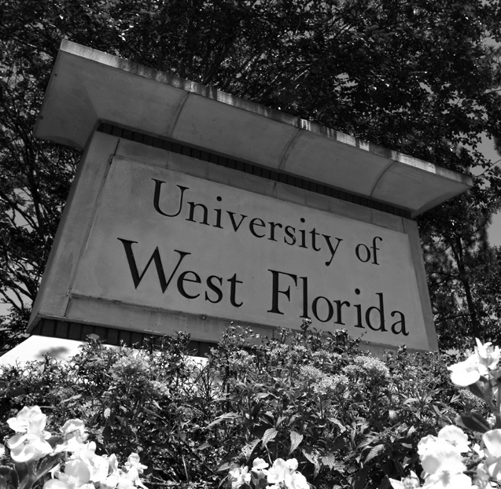

**Main Campus:**

**University of West Florida**

**11000 University Pkwy.**

**Pensacola, FL 32514**

From 110: Take exit 13 (Davis Hwy.) and go north. Stay in far left lane to follow signs to University Pkwy. Turn left onto

University Pkwy. Stay in the right lane and follow University Pkwy. until it ends. **850-474-3491**

**Historic Pensacola Campus Downtown locations:**

**J. Earle Bowden Building**

**120 Church St.**

**Pensacola, FL 32501**

Two-story building is located on Church St. off of Tarragona St. behind the T.T. Wentworth museum. PARKING IS LIMITED

There is a paid lot on the corner of Church and Tarragona. BE AWARE parking adjacent to the Bowden building because they are private parking and have Tow Away zone signs posted.

**850-595-5985**

**Florida Public Archaeology Network 207 E Main St.**

**Pensacola, FL 32501** Located just East of Tarragona St. on the corner of Main and

Barracks streets, next to The Fish

House. Parking is available behind the FPAN building, off of Barracks St., or on the east side near the park. **850-595-0050**

**Angelena's Restoranto Italiano**

**101 E Intendencia St., Pensacola, FL 32502**

Downtown Pensacola on Intendencia St. under the Southtowne Aparments between Tarragona and Jefferson Streets. **850-542-8398**

**Bayview Senior Citizens Center**

**2000 E Lloyd St. Pensacola, FL 32503** Located in East Hill at the corner of 20th and Lloyd Street on Bayou Texar.

**850-436-5190**

**Bodacious Bookstore and Cafe**

**101 E Intendencia St., Pensacola, FL 32502** Downtown Pensacola on Intendencia Street underneath the Southtowne Apartments between Tarragona and Jefferson streets. **850-446-6966**

**Bodacious Shops**

**407 S Palafox St. Pensacola, FL 32502** Downtown Pensacola. Located on South Palafox St. between East Zarragossa and East Main Streets. **850-438-7857**

**Brew Ha Ha**

**2435 N 12th Ave. Pensacola, FL 32503** Located on the corner of 12th Ave. and Scott St., 10 blocks south of Texar Dr., or 4 blocks north of Jordan St.

**850-857-9350**

**Dean Mosher Studio**

**456 Oak Ave. Fairhope, AL 36533** From Pensacola on Interstate 10 exit at the Daphne/Spanish Fort exit (#35B). Turn left onto Highway 98, a four lane road, going south for about 7 to 8 miles.

Look for Scenic 98 and the big "Welcome to Fairhope" sign with an American Flag above it. TURN RIGHT onto scenic 98. The road has two other names: Veteran’s Drive and Section Street you will pass St. James Episcopal church on the left and then about a mile later Fairhope Elementary School, also on the left. After the school, about an 1/8 of a mile, you will take a

left onto Oak St. The destination will be straight ahead. There is ample parking available on the southeast corner of Oak and Bancroft. Otherwise, carefully park along the dirt road that leads into the property. **251-928-0900**

**Emerald Coast Utilities Authority**

**9255 Sturdevant St**

**Pensacola, FL 32514**

From North Davis Highway, head east on Copter Road. In just a few blocks, turn left onto Sturdevant Avenue. Destination will be on your left.

**850-969-3348**

**Escambia County Extension Office 3740 Stefani Rd. Cantonment, FL 32533** From I-10, exit on Exit #7 (Pine Forest Rd.) and head north on Pine Forest

Rd. Proceed through the Nine Mile Rd. intersection traffic light and turn right

(east) on 9-1/2 Mile Rd. At the Stefani Rd. intersection stop sign, turn left (north). The Extension Office is on the right (corner of 9-1/2 Mile Rd. and Stefani Rd.). **850-475-5230**

**Fairhope Museum of History**

**24 N Section St. Fairhope, AL 36533** From Pensacola on Interstate 10 exit at the Daphne/Spanish Fort exit (#35B). Turn left onto Highway 98, a four lane road, going south for about 7 to 8 miles. Look for Scenic 98 and the big "Welcome to Fairhope" sign with an American Flag above it. TURN RIGHT onto scenic 98. The road has two other names: Veteran’s Drive and Section Street you will pass St. James Episcopal church on the left and then about a mile later Fairhope Elementary School, also on the left. After the school, you will

be going up a hill. Proceed into town;

turn left onto Magnolia Ave. then right at the next block onto Bancroft St. The museum is in the middle of the block on your right side. **251-929-1471**

**Hot Spot Barbecue**

**901 E La Rua St. Pensacola, FL 32501** Downtown Pensacola on the corner of 9th Ave. and La Rua St., which is three blocks south of Cervantes St. **850-497-6060**

**Humming Star Alpaca Farm**

**19700 Blueberry Lane**

**Silverhill, AL 36576**

Directions from Pensacola: Take I10 West to the Loxley Exit. At Loxley exit, go south toward the gulf. Travel to Hwy 104 in Robertsdale. Take Hwy 104 West to County Road 49. Turn south on Cty Rd

49. Travel until you come to stop sign at Cty Rd 48. Go straight at that stop sign and at that point 49 becomes Blueberry Lane. We will be less than 1/2 mile on your left, It is the only property that is entirely fenced and the barn sits 600 feet off the road. **251-214-8224**

**Indian Temple Mound**

**139 Miracle Strip Parkway Fort Walton Beach, FL 32541**

Cross the 3-mile bridge into and through Gulf Breeze and continue east on Highway 98 through Navarre and Mary Ester. Indian Temple Mound is located on Highway 98 in the center of downtown Fort Walton Beach. It’s prudent to allow about an hour and a half for the drive from Pensacola to Indian Temple Mound. **850-833-9595**

**Macaw Bird Park**

**9513 N Palafox Pensacola, FL 32534**

Go north on Palafox, crossing 9 Mile Rd. The Macaw Bird Park is about 500 feet north of 9 Mile Rd. on the left (west) side of the street. **850-478-6421**

**McGuire's Irish Pub**

**Invite a Friend!**

Current members may bring a friend to a class. Class price will apply. If your friend joins Leisure Learning, you AND your friend will receive a credit voucher toward a future class or event.

**Please Note: Schedule and location changes will be communicated through email. Be sure to check your email leading up to the event.**

**600 E Gregory St. Pensacola, FL 32501**

I-110 South, take exit 1A on the left. Merge onto Chase St., turn left onto 12th Ave., turn left onto Gregory St. Destination will be on the right. **850-433-6789**

**Mobile Carnival Museum**

**355 Government St. Mobile, AL 36602** Take I-10 west to Mobile. Take Government St. exit 27. Travel through the Bankhead Tunnel. Go approximately 4 blocks. Museum is in a large Victorian house with jesters out front. Parking lot is on the left side. Allow yourself one and a half hours to complete this trip.

**251-432-3324**

**New World Landing**

**600 S Palafox St. Pensacola, FL 32502** Take Garden St. exit from I-110S, turn left onto Palafox, Located downtown, one and a half blocks south of Main Street between Palafox and Jefferson Streets. **850-434-7736**

**Oakleigh Complex**

**350 Oakleigh Place Mobile, AL 36604** Take I-10 west to Mobile. Take Exit 25B Virginia St., turn right onto Virginia St. Turn Right onto S. Broad St., turn Left onto Selma St., turn Right onto Oakleigh Pl. Destination is on the Left. **251-432-1281**

**Old Christ Church**

**405 Adams St. Pensacola, FL 32502** Downtown Pensacola. From I-110S take Garden exit and turn left on Tarragona. Take a left on Government, church will be on your left when you reach Adams Street. Free parking along Government and Alcaniz streets or in Fountain Park. **850-687-9968**

**Pensacola Museum of Art**

**470 S. Jefferson St. Pensacola, FL 32501** Corner of Jefferson and Main St. Directly across the street from the Pensacola Little Theatre/Pensacola Cultural Center. Take I-110 to downtown Pensacola. Exit

1-C which goes on to Garden Street. At second traffic light, turn left onto Jefferson Street and follow almost to the end. The Museum of Art is on the right. For parking information: pensacolamuseum.org/visit.

**850-432-6247**

**Pensacola State College Planetarium 1000 College Blvd. Pensacola, FL 32504** Enter campus from Airport Blvd across from Steak N Shake. You will be right

in front of the planetarium. Parking is available anywhere in front of the

planetarium in building 21, except for the Green painted curbs (faculty and staff). **850-484-1238**

**Pensacola Yacht Club**

**1897 Cypress St. Pensacola, FL 32507** At Garden and Barrancas Ave., bear left on Barrancas. Turn left on L St. At stop sign, turn right onto Cypress. Yacht club is on the left side. **850-207-3877**

**Quayside Art Gallery**

**17 E Zarragossa St. Pensacola, FL 32502**

Located in downtown Pensacola on the corner of Jefferson and Zarragossa streets. Heading west on Garden street,

turn left on Jefferson street. Take a right on Zarragossa street and the destination will be on your left. **850-438-2363**

**Roy Hyatt Environmental Center 1300 Tobias Rd. Cantonment, FL 32561** From Hwy 29 and 9 Mile Rd, follow Hwy 29 North to Kingsfield Rd. Turn left on Kingsfield Rd. Follow Kingsfield Rd. for quite a long way, crossing Hwy 297 and eventually coming to Hwy 97. Turn right

on Hwy 97 and go about 1/2 to 1 mile and you will see a green sign that says Roy Hyatt Environmental Center. Turn right (Tobias Road) and you will deadend into the entrance of the RHEC. **850-937-2117**

**St. Christopher's Episcopal Church 3200 North 12th Ave. Pensacola, FL 32503** Located two blocks south of Texar on the east side of 12th. **850-433-0074**

**St. Michael's Cemetery**

**6 S Alcaniz St. Pensacola, FL 32502**

St. Michael’s Cemetery is located on the corner of Alcaniz and Garden Street.

Meet at the SW gate on Alcaniz at the corner of Garden St. Park on the corner on Alcaniz or in the lots across from the IHMC which is located at 243 Garden St. **850-436-4643**

**Studer Community Institute**

**220 W Garden St. Pensacola, FL 32502** Tall white building (formerly the Sun Trust) located downtown, two blocks west of Palafox St. Parking is available

in the lot on Spring and Chase streets

— yes there are signs indicating private parking and numbered spaces, but it

is the event parking for that building. Classroom is on the bottom floor next to the main offices. **850-359-9595**

**Swift-Coles Historic Home 17424 Swift-Coles Lane Bon Secour, AL 36511**

According to Google maps: Take I-10W to exit 5 for US-90 Alt.(Nine Mile Rd.), drive about 14 miles, take a left on County Road 87 (Joe Foley Rd.), follow the road for about 9 miles, take a right on US-98 (about 4 miles), then left on Foley Beach Express, right on Brinks Willis Rd., left onto AL-59 (McKenzie St.), right on to Co. Rd. 10, left on Bon Secour Highway, left onto Co. Rd. 49, left onto Swift Coles Lane, destination will be on the left. **251-949-5550**

**The Montessori School of Pensacola 1010 N 12th Ave. Pensacola, FL 32501** Located in East Hill on 12th Ave. between Gonzalez and De Soto streets.

**850-469-8138**

**W.R. Taylor Brick Company**

**17 Manresa St. Pensacola, FL 32502** Downtown Pensacola at Garden exit from I110S, take very first left on Manresa Street, location will be on your right.

**850-432-6163**

**WEAR Channel 3**

**4990 Mobile Hwy. Pensacola, FL 32507**

Drive west from Pensacola on Highway 90 past Fairfield and past the WalMart store. WEAR-TV is on the north side of the highway. Security is evident at the building. The secretary electronically allows the door to open after ascertaining the identity of each individual. **850-456-3333**

**Weeks Bay Reserve**

**11300 Hwy 98 Fairhope, AL 36532** Take US 98 west all the way to the Reserve. You will go through several towns: Lillian, Elberta, Foley, Magnolia Springs, cross a large bridge and the Reserve Visitors Center is on the left once you cross the bridge. You will take a right and follow the road to go underneath the bridge you just crossed to reach the marina. According to GoogleMaps it is about 47 miles from UWF. **850-928-9792**

**Have an idea for a class or tour?**

We are always looking for instructors in Basic Computers, U.S. and International History, Fine Arts, Music, Theater, Social Media and Behind-the-Scenes Tours. **Email** [**leisurelearning@uwf.edu.**](mailto:leisurelearning@uwf.edu)

**VOLUNTEERS**

#### Leisure Learning thrives

**on the strength of our volunteers.**

Spring 2020 Instructors

Kym Atwood

Dr. Randy Bobbitt Beth Bolles

Bob Booth Cheryl Bowen Patrick Broadus Jack Canavan

Bob & Joan Cochrane Dr. Alfred Cuzán

Pam Davis Dean DeBolt

Michael DeMaria, Ph.D James Donnell

Dr. Suzette Doyon Dr. Athena du Pre

Katie Fahrenbruch Nick Farcas Nancy Fetterman

J.T. Fraley Tom Garner

Nannette Hammond Dr. Richard Harper John Hodgdon II David Hoffman Blake Howerton Cheri Hulbek

Perry Hunter Susan Johnston Pierre Kaufke Rheta Kirk

Tricia Kruse Larry Manning John Markowitz Andy Marlette

Stephanie McNeill, MPS Jena Melancon

Crissy Nettles Connie O'Connor Molly O'Connor George Peeterse Renée Perry

Dr. David Ramsey Jim Roberts

Bob Robinson Robin Rowan

Dr. Matthew Schwartz Dr. Augusta Simon Lauren Smith

Gordon Sprague Margo Stringfield Dr. Justin Sturgeon Mike Thomin

Dr. Louise Tolbert Charles Tucker Angela Underwood Bill Vilona

Dave Walby Hayden Ward

Dr. Michelle Williams

Curriculum Council

Pam Davis James Godfrey Jim Hearn David Hoffman

Dee Ingram Robert Kugelman Bob Robinson

Advisory Board

Nancy Clark Marie Robinson

**Volunteer Opportunities**

Curriculum committee members earn a free class for every class they organize. No minimum number required! Responsibilities include attending 2-3 meetings per semester, contacting potential instructors, occasionally take attendance and be a supportive presence in the classroom.

**To get involved, send an email to** [**leisurelearning@uwf.edu**](mailto:leisurelearning@uwf.edu) **or call 850.473.7468.**

**Want to teach**

**a Leisure Learning class?**

We are always looking for instructors in Basic Computers, U.S. and International History, Fine Arts, Music, Theater, Social Media and Behind-the-Scenes Tours.

**Have an idea for a class? Visit the “Want To Get Involved” page at uwf.edu/leisurelearning and submit an online course proposal.**

## SPRING 2020 REGISTRATION FORM

**Leisure Learning**

uwf.edu/LeisureLearning | e-mail: [leisurelearning@uwf.edu](mailto:leisurelearning@uwf.edu) | 850.473.7468

THREE EASY WAYS TO REGISTER!

* + ***Online*** - uwf.edu/leisurelearning
  + ***Mail*** - Fill out the registration form.
  + ***By Phone*** - To pay by Visa, Mastercard or American Express, call the Leisure Learning office at 850.473.7468.

OFFICE HOURS

Mon - Fri, 8 a.m. to 5 p.m.

**Building 77, Room 149**

11000 University Parkway

Pensacola, FL 32514

***Classes selections listed on reverse side.***



* Check this box if address/info has changed

Name

Phone #

Address

City, State, Zip

Email

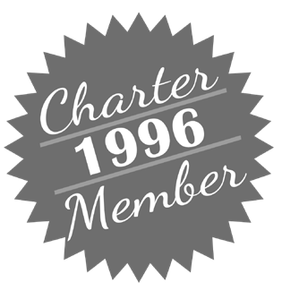Members who joined LL in **1996** will always remain Charter Members, but your membership must be renewed annually. Please consider the discounted

$10 membership dues to help cover printing and postage costs.

The $35 annual membership fee covers twelve months from the date you join.

* $35.00 - New Member
* $35.00 - Renew Annual Membership
* No fee - Membership Dues are current

**Charter Membership** *(Joined LL in 1996)*

* $10.00 - Renew Charter Member
* No fee - Renew Charter Member Gratis

Total Class Tuition: Membership Dues:

**Total Payment Enclosed:**

**Writing a check for class?**

Many Leisure Learning events and classes fill up quickly and result with a waiting list. If you are paying by check, please visit uwf.augusoft. net or call Student Support 473-7468 to check availability before mailing payment.

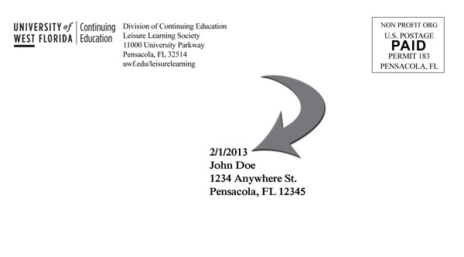

Make check payable to: **Leisure Learning**

Mail this form along with your check to:

University of West Florida Leisure Learning (Bldg. 77/ 149)

11000 University Pkwy., Pensacola, FL 32514

Making a donation?

*Please enclose a separate check made out to UWF Foundation - Leisure Learning.*

*Returning Members,* your membership expiration date is shown on your mailing label.

**Never stop learning! Register today and enjoy quality instruction and social engagement!**

**SPRING 2020 REGISTRATION FORM**

uwf.edu/LeisureLearning | e-mail: [leisurelearning@uwf.edu](mailto:leisurelearning@uwf.edu) | 850.473.7468

* **$180** Unlimited Classes Option
* **$30** Lunch N Learn: Meet the Artists of *Giovanni\**
* **$30** Lunch N Learn: Meet the Artists *Trovatore\**

**Mondays**

* **$12** Bodacious Bookstore and Cafe
* **$12** Calling All Bookies
* **$12** Chaos and Cartooning with Andy Marlette
* **$12** ECUA Recycling Facility Tour - Session #1
* **$12** ECUA Recycling Facility Tour - Session #2
* **$12** Finding Peace Within: Mediation and Mindfulness
* **$12** Gálvez!
* **$15** Indian Temple Mound Museum*
* **$12** Laughter and Leading
* **$25** Learning to Play the Recorder
* **$12** Make a Difference: Volunteer
* **$12** Quayside Art Gallery
* **$25** Recorder Ensemble Series
* **$12** St. Michael's Cemetery
* **$15** Swift-Coles Historic Home Tour*
* **$12** The Voluntary Exile of Free Negroes of Pensacola in 1858
* **Free** UWF Archives & W. FL Center John C. Pace Library Tour: Artists and Art
* **$15** Voices of the American Spirit: Willa Cather

**Tuesdays**

|  |  |  |
| --- | --- | --- |
| ❑ | **$12** | All Adventures Don't Happen in Wonderland |
| ❑ | **$12** | Angelena's Restoranto Italiano |
| ❑ | **$25** | Beginning Portrait Drawing* |
| ❑ | **$25** | Bodacious Chef: Nick Farcas* |
| ❑ | **$12** | Deadman's Island: Pensacola Bay's Unique Landform |
| ❑ | **$12** | Eden Energy Medicine |
| ❑ | **$25** | Executive Brain and Whole Person Lifestyling |
| ❑ | **$12** | Hangar Flying: Improvements in Aviation Safety |
| ❑ | **$12** | Hot Spot Barbecue |
| ❑ | **$12** | How Does Your Garden Grow? |
| ❑ | **$12** | Pensacola Museum of Art: John Markowitz |
| ❑ | **$12** | Plan for your Future, Make it Happen |
| ❑ | **$12** | Planning for Long Term Care |
| ❑ | **$12** | Simple and Effective Art of EFT — Tapping 1.0 |
| ❑ | **$12** | Simple and Effective Art of EFT (Part Two) 2.0 |
| ❑ | **$12** | Uncle Sandy's Macaw Bird Park - Session #1* |
| ❑ | **$12** | WEAR TV 3 Tour - Session #1 |
| ❑ | **$12** | WEAR TV 3 Tour - Session #2 |
| ❑ | **$25** | Weeks Bay Reserve Pontoon Boat Tour - Session #1* |

**Wednesdays**

* **$12** America’s Cup Challenge in Pensacola
* **$25** Bodacious Shops — Wine and Cheese*
* **$30** Charcoal Drawing with Larry Manning*
* **$12** Communication Through Dance
* **$30** Conte Crayon Drawing with Larry Manning*
* **$25** Divine Life Lessons: Uncovering Your Sacred Self
* **$12** Go Argos!: UWF Football with FL Sports Hall of Famer Gordon Sprague
* **$12** Great American Speech Series: Martin Luther King Jr.
* **$12** Gulf Coast Citizen's Diplomacy Council
* **$15** Historic Pensacola Village Tour*
* **$12** Keeping Bonsai Alive
* **$12** Montessori Education 101
* **$12** Pensacola Yacht Club History
* **$12** Roy Hyatt Environmental Center Tour - Session #1
* **$12** Roy Hyatt Environmental Center Tour - Session #2
* **$12** Stonewall Jackson’s Shenandoah Valley Campaign
* **$15** Storybook Castles and Fairhope History Museum - Session #1*
* **$15** Storybook Castles and Fairhope History Museum - Session #2*
* **$12** Uncle Sandy's Macaw Bird Park - Session #2*
* **Free** UWF Archives & W. FL Center John C. Pace Library Tour: The American Presidents
* **$25** Weeks Bay Reserve Pontoon Boat Tour* - Session #2

**Thursdays**

|  |  |  |
| --- | --- | --- |
| ❑ | **$55** | Bavarian's Wirtshaus and Destin History |
|  |  | & Fishing Museum* |
| ❑ | **$12** | Blue Wahoos Senior Writer - Bill Vilona |
| ❑ | **$30** | Bocce Ball for All - 5 Sessions |
| ❑ | **$25** | Create-a-Craft: Sea Angels* |
| ❑ | **$12** | Hangar Flying: Where are We? |
| ❑ | **$12** | Healthy Living for Your Brain and Body: Tips from the Latest Research |
| ❑ | **$15** | Humming Star Alpacas* |
| ❑ | **$12** | McGuire's Irish Pub & Brewery Tour - Session #1 |
| ❑ | **$12** | McGuire's Irish Pub & Brewery Tour - Session #2 |
| ❑ | **$12** | Pensacola Backyard Homestead |
| ❑ | **$12** | Richmond: Primary Arms Producer for the South |
| ❑ | **$25** | Scenic Highway Trolley Tour - Session #1* |
| ❑ | **$25** | Scenic Highway Trolley Tour - Session #2* |
| ❑ | **$25** | Scenic Highway Trolley Tour - Session #3* |
| ❑ | **$12** | Supreme Court Preview: Cases to Watch in the 2020-21 Term |
| ❑ | **$15** | Tales of the Maya Skies: Pensacola State College Planetarium* |
| ❑ | **$12** | Tax-Free Investing: It's Not What You Make, It's What You Keep! |
| ❑ | **$15** | W.R. Taylor Brick Company - Session #1 |
| ❑ | **$15** | W.R. Taylor Brick Company - Session #2 |

**Fridays**

|  |  |  |
| --- | --- | --- |
| ❑ | **$20** | Anticipation 2020 |
| ❑ | **$12** | Florida's Current Economic and Legislative Outlook |
| ❑ | **$12** | Harmful Algal Blooms |
| ❑ | **$25** | Historic Oakleigh House and Mobile Carnival Museum* |
| ❑ | **$12** | How Did Artists Gain Perspective? |
| ❑ | **$12** | Illuminated Medieval Manuscripts  and What They Reveal About the Culture |
| ❑ | **$45** | On the Other Hand...Current Affairs Discussions |
| ❑ | **$12** | The Rise of the Populist Middle |
| ❑ | **$12** | Topics in Contemporary Political Science |
| ❑ | **$20** | What Ever Happened to Free Speech? |

*\*Not available on the all-inclusive Unlimited Classes option.*

**Bring a Friend!** Current members may bring a friend to a class. The class price will apply. If your friend joins Leisure Learning, you AND your friend will receive a credit voucher toward a future class or event.

**INFORMATION**

uwf.edu/LeisureLearning | e-mail: [leisurelearning@uwf.edu](mailto:leisurelearning@uwf.edu) | 850.473.7468

THREE EASY WAYS TO REGISTER!

* + ***Online*** - uwf.edu/leisurelearning
  + ***Mail*** - Fill out the registration form.
  + ***By Phone*** - To pay by Visa, Mastercard or American Express, call the Leisure Learning office at 850.473.7468.

OFFICE HOURS

Mon - Fri, 8 a.m. to 5 p.m.

**Building 77, Room 149**

11000 University Parkway

Pensacola, FL 32514



UNIVERSITY OF WEST FLORIDA

**Nautilus Card Benefits**

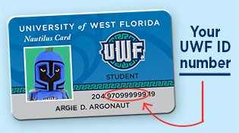As a Leisure Learning member, you are eligible to purchase a UWF Nautilus card for only $10.

The official UWF identification card can be used for:

* + - Checking out books and using the electronic databases at the UWF Library. **library.uwf.edu**
    - An ID for campus events, including $5 admission fees to UWF Center for Fine and Performing Arts events. **uwf.edu/cfpa**
    - Access to the Health, Leisure & Sports facility with purchase of gym membership — $35/monthly or $125/semester. **uwf.edu/recreation**
    - 10% discount at Boneheads Fire Grilled.

**boneheadspensacola.com**

**How do I acquire my Nautilus card?**

1. Take your membership receipt to the UWF cashier’s office (Building 20E) to purchase the $10.00 card.
2. Take your payment receipt, membership receipt, and a government issued photo ID to the Nautilus Card office (Building 20W) to have your picture taken and a Nautilus Card issued.

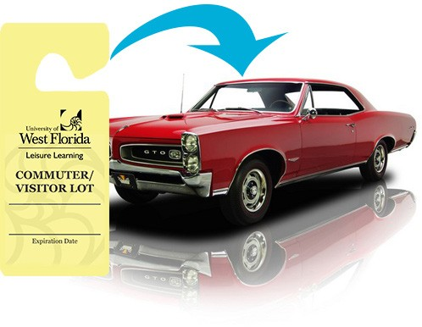

###### UWF Parking Permits

Leisure Learning courses at UWF do require you to have a parking permit. The cost of the permit is included in your Leisure Learning membership and will expire at the same time your membership does. Participants are allowed to park in any COMMUTER parking lot on campus. Please pay close attention to the signs for correct parking areas.

For more parking information visit: ***uwf.edu/parking***

###### 48-hour cancellation and refund policy

If you are unable to attend your registered class, you must notify the Leisure Learning office at least **48-hours** in advance of the class in order to receive a refund or credit toward a future class. Any cancellation given less than

**48-hours** in advance will not receive a refund or credit. Please be courteous to your volunteer instructors and fellow members by adhering to this policy. ***Please Note:*** *For events that require Leisure Learning to PREPAY, refunds cannot be processed if you are unable to attend unless there is someone on the waiting list to take your place.*

Register online at **uwf.edu/LeisureLearning** | 850.473.7468 | Spring 2020 35



**Leisure Learning**

11000 University Pkwy.

Building 77, Room 149

Pensacola, FL 32514 uwf.edu/leisurelearning

NON PROFIT ORG US POSTAGE PAID PENSACOLA, FL PERMIT NO 183

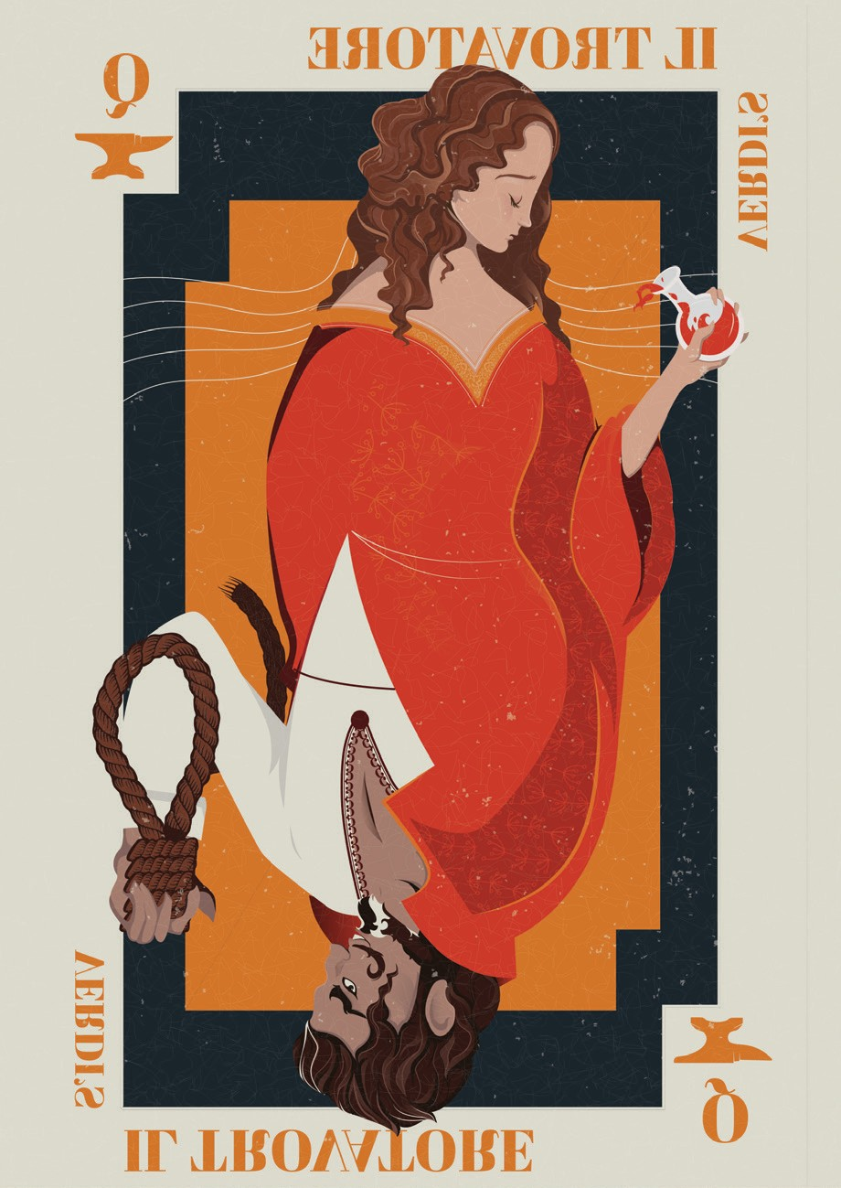**LUNCH ‘N’ LEARN EVENT:**

MEET THE ARTISTS OF

*IL TROVATORE*

**10-March | Tue 11:30 AM**

**New World Landing Banquet Hall | $30**

Verdi’s hot-blooded thriller emphasizes the “grand” in grand opera. The innocent Leonora is caught in a love triangle from which there is no escape. Pensacola Opera's Maestro Jerome Shannon and Education Director Cody Martin will give an overview of *Il Trovatore* and introduce the principal artists.

Excerpts from the upcoming production will be performed by Pensacola Opera's Artists in Residence.

***Invite your friends and family! Leisure Learning membership is not required to attend.***

**Reservations required in advance through March 3, 2020**.

*\*Not available on the all-inclusive Unlimited Classes option.*